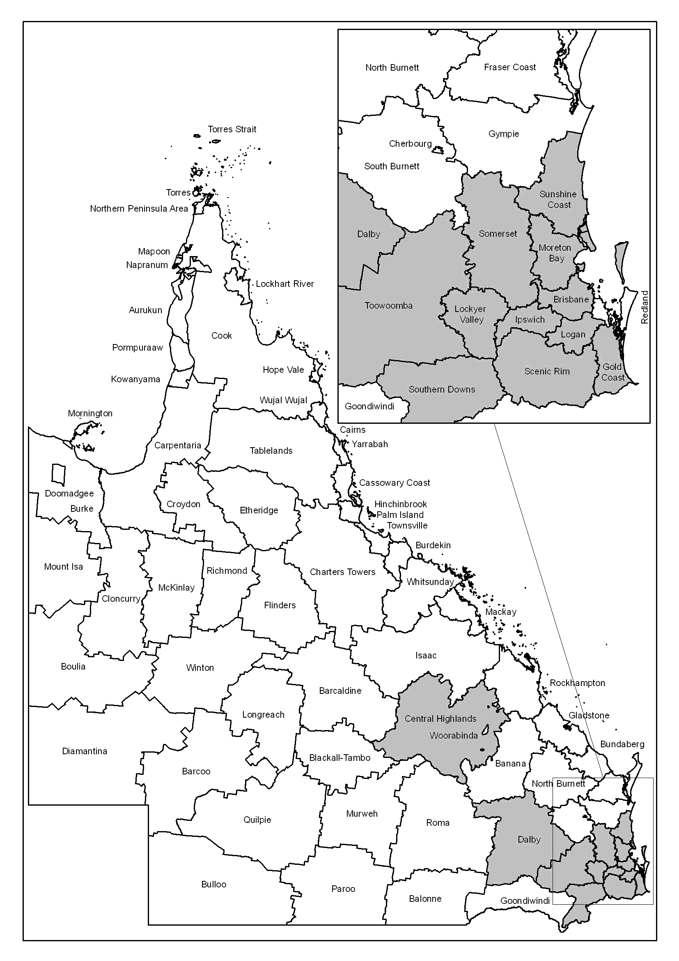
Event Timing and Location –

Severe storm activity and associated flooding commencing on 16 November 2008 through to 22 November 2008 in Queensland.

Assistance Activated –
The Minister for Emergency Services,
The Honourable Neil Roberts MP activated the Commonwealth/State Natural Disaster Relief and Recovery Arrangements (NDRRA).

NDRRA Relief Measures Activated
- Counter Disaster Operations;
- Disaster Relief Assistance Scheme;
- Restoration of Essential Public Assets;
- Associations Natural Disaster Relief Scheme; and
- Concessional Loans to Small Businesses for Carry-on and Re-establishment Costs

* Details of NDRRA relief measures and NDRRA Administering Authorities are available from:

http://www.disaster.qld.gov.au/publications/pdf/NDRRA%20Queensland%20Disaster%20Relief%20&%20Recovery%20Arrangements%202007-08.pdf

Area formally defined (by the Minister for Emergency Services, the Honourable Neil Roberts MP) for receipt of NDRRA Relief Measures –

“Communities within Queensland affected by severe storms and associated flooding on 16 November 2008 through to 22 November 2008”.

Local Government areas:

- Brisbane City Council | - Somerset Regional Council
- Moreton Bay Regional Council | - Logan City Council
- Scenic Rim Council | - Sunshine Coast Regional Council
- Ipswich City Council  - Toowoomba Regional Council  - Gold Coast City Council  - Southern Downs Regional Council | - Lockyer Valley Regional Council  - Dalby Regional Council  - Central Highlands Regional Council

