Feedback and Complaints: Direct Personal Response

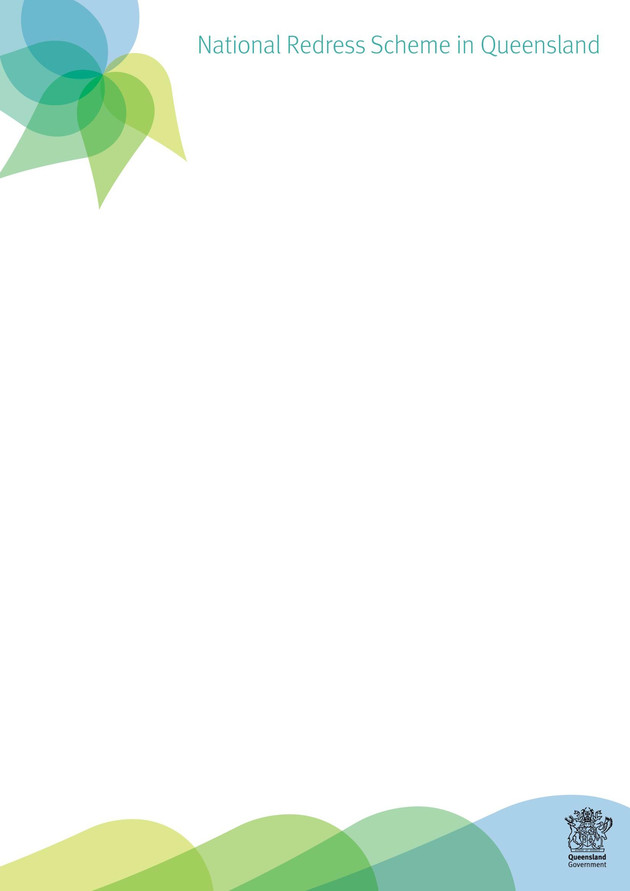
We would like to hear from you
As a responsible institution participating in the National Redress Scheme, we wish to provide the best possible Direct Personal Response and service to you. We are interested in hearing and learning from you about your experience and how we can improve our service and response.

How can I provide feedback?
You can contact the Direct Personal Response Team by calling (07) 3097 5707 (Monday to Friday, 9am – 5pm, excluding public holidays) or via email directpersonalresponse@cyjma.qld.gov.au
We welcome feedback from you about improvements we can make to the Direct Personal Response, with respect to:
- your experience
- our contact and communication with you
- the facilitation
- the response provided by the representative
- follow up support
- management of information and privacy
- any aspect of the Direct Personal Response process.
We are interested to hear from you about aspects of the Direct Personal Response or the service that you found helpful and wish to compliment, as well as what you may have found unhelpful.

How do I make a complaint?
If you have a complaint or are unsatisfied with our service, we do want to hear from you. We encourage you to start by raising your concerns with our Direct Personal Response team and the person you have been working with. Alternatively, you may prefer to raise your concern directly with the Direct Personal Response Practice Manager, by either calling (07) 3097 5707 or via email directpersonalresponse@cyjma.qld.gov.au

What happens next?
We will listen to you and every effort will be made to resolve your complaint in a way that is satisfactory to you. You can expect the response to be prompt, fair and professional.
Some complaints are easily managed, others may require further investigation. We may need to request additional information from you to help us better understand the issue or concern. We will keep you informed throughout the process and you can check on its progress at any time.
We will let you know the outcome and any actions we have taken or will take. We are committed to learning from you and improving our service.


Can I take my complaint further?
If you are dissatisfied with how we have handled your complaint, or the outcome, you can request that the Director of the Redress Coordination/Secretariat Unit reviews the complaint and the outcome.
If following this review you are still dissatisfied, you can contact the department’s Complaints Unit by emailing feedback@cyjma.qld.gov.au or phone (07) 3097 5201.
Finally, if you are still dissatisfied, you can request an external review by the Queensland Ombudsman.

How do I contact the Queensland Ombudsman?
Email - ombudsman@ombudsman.qld.gov.au Phone - (07) 3005 7000 or 1800 068 908
Online - https://www.ombudsman.qld.gov.au/ Mail – Queensland Ombudsman, GPO Box 3314, Brisbane, Qld, 4001.

What if my complaint is about something else?
National Redress Scheme complaints: If your complaint is about the National Redress Scheme you will need to contact the Commonwealth Department of Social Services by emailing complaints@dss.gov.au.

Privacy:
If you have questions or feedback about the department’s privacy and security practices please contact Privacy Complaints via email privacy@cyjma.qld.gov.au or phone (07) 3097 5609.

Right to Information, redress and screening:
If you have feedback regarding Right to Information, subpoenas or an administrative release, please contact the department.
Email - rti@cyjma.qld.gov.au Phone - (07) 3097 5603
Free call -1800 809 078

How can I access more information?
For more information about how the Department of Child Safety, Youth and Women manages complaints you can contact the Complaints Unit by:
Email - feedback@cyjma.qld.gov.au Phone - (07) 3097 5201.
Online - https://www.cyjma.qld.gov.au/contact- us/compliments-complaints
Mail - Complaints Unit
Department of Children, Youth Justice and Multicultural Affairs, Locked Bag 3405, Brisbane, Qld, 4001.

What additional support is available?
If you require support to hear or communicate in order to provide feedback or make a complaint, you can access the National Relay Service on 1800 555 660.
If you need an interpreter, you can use the Translating and Interpreting Service on 131 450.

