MOVE TO HIGHER GROUND
[Location]
Flood (Descriptor)
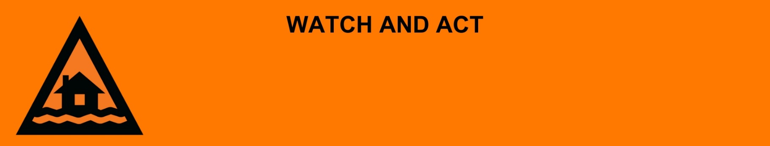
Issued: [time, day, date, year]
Next update: [time, day, date, year] or as the situation changes.

[Insert issuing agency] advises people in the following area(s):
- [Add location(s) here]

to MOVE TO HIGHER GROUND by [time, date] due to the [minor/moderate/major/flash] flooding on the [river/street/area name]. An [evacuation centre/registration point/assembly area] has been set up here [insert link/area]

For emergency help in floods and storms, call the QLD SES on 132 500 or download the SES Assistance QLD App. In life threatening situations, call Triple Zero (000) immediately.

What are we expecting?
The Bureau of Meteorology advises [insert BOM prediction here, including time/when it’s expected to hit].
- Once the floodwater reaches [X] metres, expected at [Time AM/PM today/tomorrow date], safe evacuation routes are likely to be cut off.

What you need to do:
- Go and stay in a safe place in a high part of [town/your suburb/your city] away from creeks and rivers.
- Advise your family, friends, or neighbours of your location.
- Decide how you will get to your safe place. If you come to a flooded road, turn around and go another way. Do not drive through floodwater.

If you are inside and can’t leave safely:
- Stay inside and watch for rising flood water.
- If floodwater comes inside, move to a higher point like the kitchen bench or second storey and call Triple Zero (000).

If you find it hard to move quickly or have special or medical needs:
- Use your Person-Centred Emergency Plan (P-CEP) now if you have one.
- Make sure you have enough medicine for at least one week.
- If anyone in your house uses powered medical equipment, like a dialysis machine or ventilator, decide now where you will go in case you lose power.
- Call your support person or service to organise transport if you need to leave.
- Leaving early is safer than waiting.

If it is still safe, prepare your home quickly before you leave:
- Lift important things onto benches, tables, high shelves or upstairs.
- Block toilets, sinks and drains with sandbags to stop sewerage backflow if you can.
- Help others if you can.

If you are a tourist, visitor, camper or caravanner:
- Campers and caravanners should start packing up now.
- If you do not need to be in the warning area, leave now. Check road conditions and plan your route before you leave.
- Be ready to move if the situation gets worse.
- Ask the campground owners whether the site floods.
- Check your surroundings of water catchments, and monitor conditions.

For more information:
- Follow our local council disaster dashboard here [insert disaster dashboard link].
- Listen to your local radio [add ABC local radio or other station and frequency].
- For power outage information go to energex.com.au or ergon.com.au/network [select energy provider].
- Check the latest weather, warnings, rainfall, and river heights at the Bureau of Meteorology Queensland website.
- For information on what to do during a disaster visit the Get Ready Queensland website (During a Disaster).
- Check road closures at the QLD Traffic website or for phone service call 13 19 40.
- Check disruptions to public transport at the Translink website.

