|  |
| --- |
| **THREAT IS REDUCED** |
|  |
| **[Location]** |
| **Severe Weather (Descriptor)** |

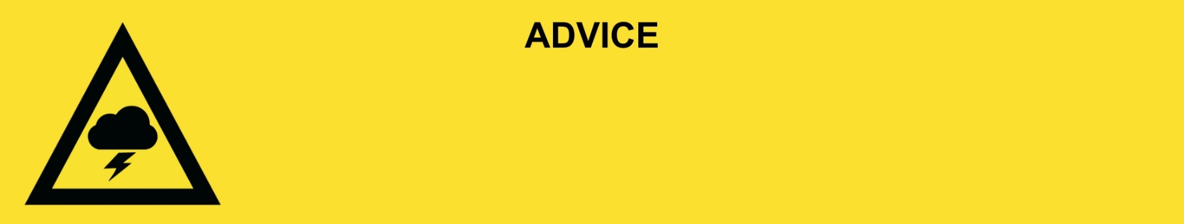

**Issued:** [time, day, date, year]

**Next update:** [time, day, date, year] or as the situation changes or This will be the last warning issued for this event.

[Insert issuing agency] advises that for people in the following location(s)**:**

* [Add location(s) here]

the **THREAT IS REDUCED**. The severe weather has passed. You can now go outside but be careful of dangers and hazards left behind from the storm.

**For emergency help in floods and storms, call the QLD SES on 132 500 or download the SES Assistance QLD App. In life threatening situations, call Triple Zero (000) immediately.**

**What we are expecting:**

* There is significant damage in the area.
* Power and water are off in some places. These will be restored when it is safe.
* There may be fallen trees, branches, and debris on the roads.

**What you should do:**

* Stay away from creeks, rivers, and drains.
* Travel slowly, plan your route carefully to avoid any flooded or damaged roads and allow extra travel time. Damage to roads and buildings may still exist in your area.
* Be aware of road hazards including tree branches and debris.
* Check in on your neighbours, animals, and livestock if safe to do so.

**If your property has been damaged:**

* Make sure your property is safe before entering. Check for damage to windows, walls and the roof and be careful of potential dangers including asbestos.
* Make sure the electricity and gas are turned off before going inside.
* If power points, electrical equipment, appliances or electrical hot water systems have been exposed to water or are water damaged in any way, they must be inspected by a qualified electrician before use.
* Gas appliances and gas bottles that have been exposed to floodwater should be inspected for safety before use.
* Wear suitable protective clothing, including boots and gloves when cleaning up.

**Support and recovery help:**

* For flood emergency help, call the SES on 132 500 or download the SES Assistance Queensland app.
* Go to [insert council name and website] for clean-up and recovery information.
* Recovery services are available [insert details of organisations actively involved; ideally on the ground]:
  + Agency – Location, full address and times.
* For general relief and recovery information go to the [Get Ready Queensland website (After a Disaster)](https://www.getready.qld.gov.au/after-disaster).
* Natural disasters can affect your mental health. If you need help, call any of these groups:
* Lifeline: Go to [lifeline.org.au](https://www.lifeline.org.au/) or phone 13 11 14.
* Beyond Blue: Go to [beyondblue.org.au](https://www.beyondblue.org.au/) or phone 1300 224 636.
* Kids Helpline: Go to [kidshelpline.com.au](https://kidshelpline.com.au/) or phone 1800 551 800.

**For more information:**

* Follow our local council disaster dashboard here [insert disaster dashboard link].
* Listen to your local radio [add ABC local radio or other station and frequency].
* For power outage information go to [energex.com.au](https://qldpolice.sharepoint.com/sites/EMC-PublicInfoWarnings-TQPS/Shared%20Documents/General/WARNINGS/Templates/NEW%20&%20IMPROVED%20TEMPLATES%20(SES%20INSPIRED)/Final%20Flood%20Templates%2012092024/energex.com.au) or [ergon.com.au/network](https://qldpolice.sharepoint.com/sites/EMC-PublicInfoWarnings-TQPS/Shared%20Documents/General/WARNINGS/Templates/NEW%20&%20IMPROVED%20TEMPLATES%20(SES%20INSPIRED)/Final%20Flood%20Templates%2012092024/ergon.com.au/network) [select energy provider].
* Check the latest weather, warnings, rainfall, and river heights at the [Bureau of Meteorology Queensland website.](http://www.bom.gov.au/qld/)
* Check road closures at the [QLD Traffic website](http://www.qldtraffic.qld.gov.au) or for phone service call 13 19 40.
* Check disruptions to public transport at the [Translink website](https://translink.com.au/service-updates).