|  |
| --- |
| **AVOID THE AREA** |
|  |
| **[Location]** |
| **Flood (Descriptor)** |

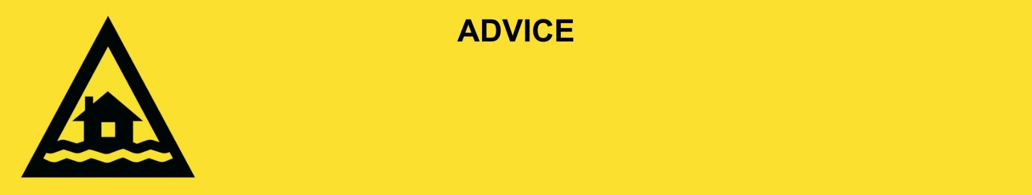

**Issued:** [time, day, date, year]

**This will be the last warning issued for this flood in [location].**

[Insert Issuing Agency] advises that people from the following area(s):

* [Add location(s) here]

should **AVOID THE AREA.** You should avoid the area the area as flood damage can be widespread.

**What we are expecting:**

* Roads and buildings have been badly damaged.
* Power and water are off in some places. These will be restored when it is safe.
* There is a lot of mud and rubbish on the ground and in the water.
* There could be more snakes, spiders, and rats inside.

**What you need to do:**

* Stay away from creeks, rivers, and drains.
* Drive slowly, plan your route carefully to avoid any flooded roads and allow extra travel time.
* Never drive, walk, ride, play or swim in flood water. If it’s flooded, forget it.
* Be aware of road hazards including mud and debris.
* Check in on your neighbours, animals, and livestock if safe to do so.
* Stay away from the area unless you live or work there, or you are helping.

**Support and recovery help:**

* For flood emergency help, call the SES on 132 500 or download the SES Assistance Queensland app.
* Go to [insert council name and website] for clean-up and recovery information.
* Recovery services are available [insert details of organisations actively involved; ideally on the ground]:
  + Agency – Location, full address and times.
* For general relief and recovery information go to the [Get Ready Queensland website (After a Disaster)](https://www.getready.qld.gov.au/after-disaster).
* Natural disasters can affect your mental health. If you need help, call any of these groups:
  + Lifeline: Go to [lifeline.org.au](https://www.lifeline.org.au/) or phone 13 11 14.
  + Beyond Blue: Go to [beyondblue.org.au](https://www.beyondblue.org.au/) or phone 1300 224 636.
  + Kids Helpline: Go to [kidshelpline.com.au](https://kidshelpline.com.au/) or phone 1800 551 800.

**For more information:**

* Follow our local council disaster dashboard here [insert disaster dashboard link].
* Listen to your local radio [add ABC local radio or other station and frequency].
* For power outage information go to [energex.com.au](https://qldpolice.sharepoint.com/sites/EMC-PublicInfoWarnings-TQPS/Shared%20Documents/General/WARNINGS/Templates/NEW%20&%20IMPROVED%20TEMPLATES%20(SES%20INSPIRED)/Final%20Flood%20Templates%2012092024/energex.com.au) or [ergon.com.au/network](https://qldpolice.sharepoint.com/sites/EMC-PublicInfoWarnings-TQPS/Shared%20Documents/General/WARNINGS/Templates/NEW%20&%20IMPROVED%20TEMPLATES%20(SES%20INSPIRED)/Final%20Flood%20Templates%2012092024/ergon.com.au/network) [select energy provider].
* Check the latest weather, warnings, rainfall, and river heights at the [Bureau of Meteorology Queensland website.](http://www.bom.gov.au/qld/)
* Check road closures at the [QLD Traffic website](http://www.qldtraffic.qld.gov.au) or for phone service call 13 19 40.
* Check disruptions to public transport at the [Translink website](https://translink.com.au/service-updates).