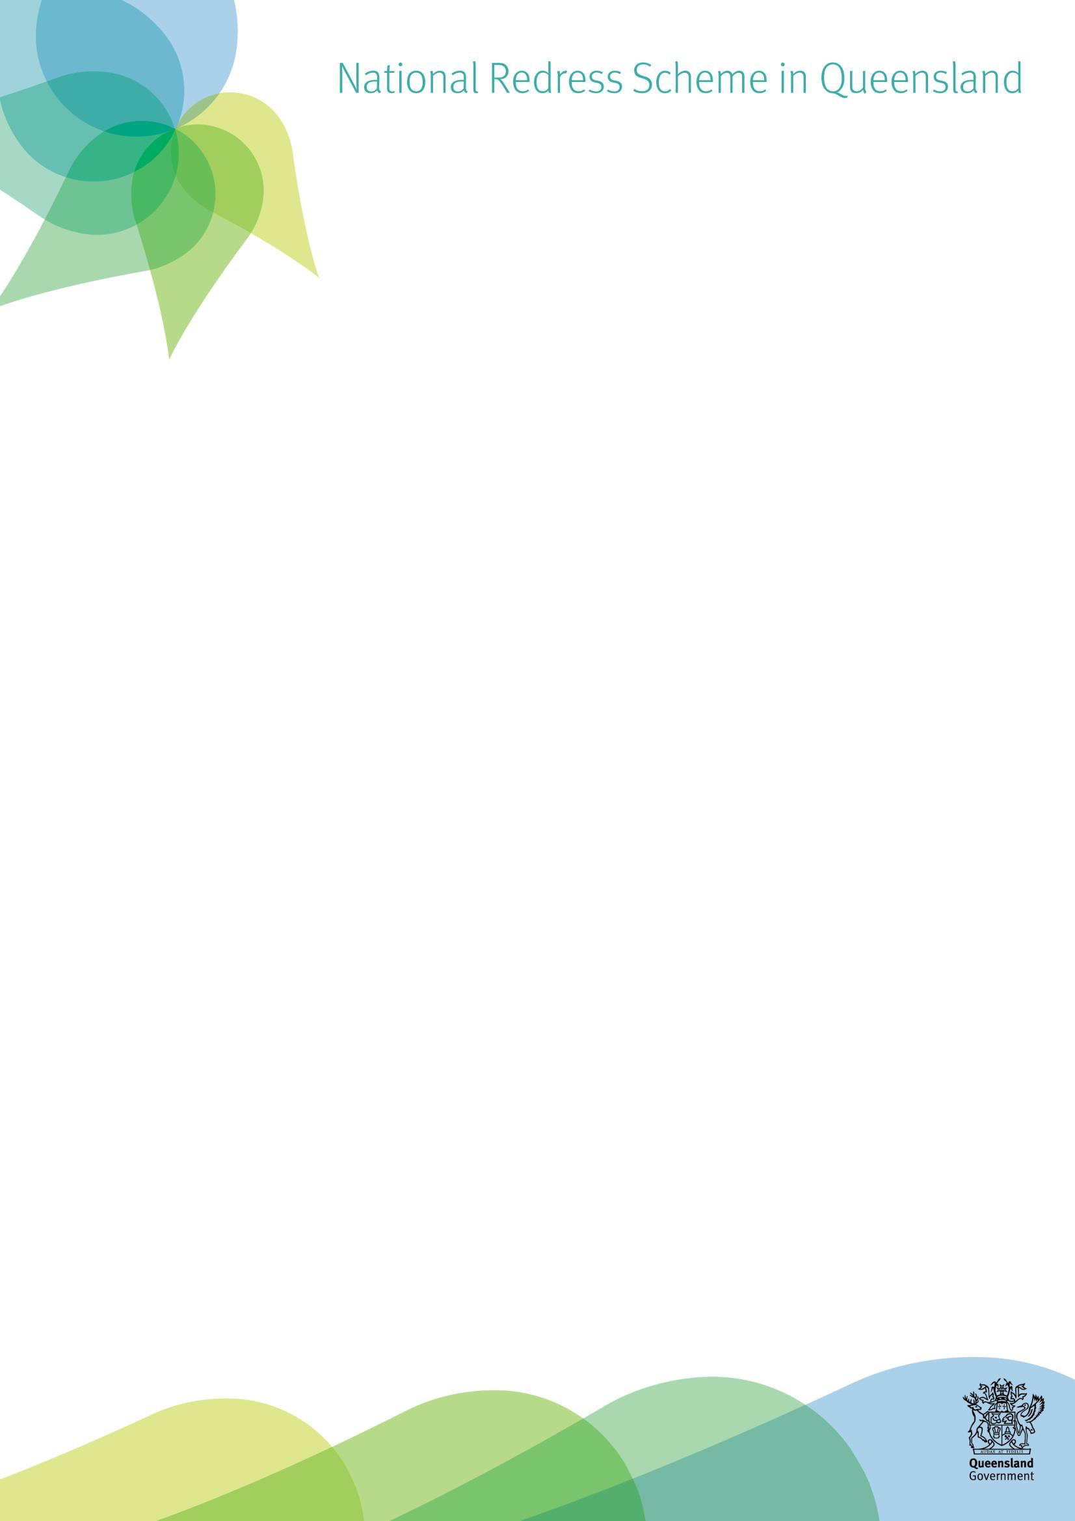

Privacy and Confidentiality

We are committed to respecting your privacy, and the confidentiality of information that is provided as part of the National Redress Scheme Direct Personal Response process.

# Why do we collect personal information?

We request and collect information from you in order to support provision of a Direct Personal Response that will meet your particular needs, hopes and expectations and be meaningful for you.

It is always your choice what information you choose to share with us. If you are unsure why we are asking for information, you can ask us to explain how we believe the information will be useful for the Direct Personal Response.

# What information do we collect?

When you sign a letter of acceptance and tick the box indicating you would like a Direct Personal Response, the National Redress Scheme automatically provides us with the below information:

* name,
* date of birth,
* postcode,
* offer of redress,
* the institution/s (that the department is responsible for), and
* whether you have accepted an offer of access to Counselling and psychological care.

We believe it is important that we only have access to additional information with your permission. The Direct Personal Response facilitator will not seek to access information included in your Redress application form without your permission. This is one way we are prioritising **your choice** about what information we have access to and when.

# What records are kept?

It is our responsibility to keep accurate records about our contact with you and anyone else involved in the Direct Personal Response process. This may include:

* information about your hopes and preferences for the Direct Personal Response, your preferred travel arrangements and contact details,
* the name and contact details of a support person (if you have one),
* records of meetings and contact by text, phone, emails, or letters,
* documents that you provide us with, and
* any other information relevant to the Direct Personal Response.

# Is my personal information kept private?

People who are directly involved with facilitating, organizing, or participating in the Direct Personal Response will only have access to information that is relevant to their role. The National Redress Scheme legislation places an obligation on us as a responsible institution to keep all aspects of the Direct Personal Response process private and confidential, unless:

* all participants agree for the information to be shared; or
* it becomes apparent during that there is an actual or potential threat to someone’s health and/or safety.

You, as the person receiving the Direct Personal Response, are not bound by these obligations, restrictions or responsibilities.

As a participant in the National Redress Scheme, we are required to provide de-identified statistical data, including:

* how many people have requested and received a Direct Personal Response,
* types of Direct Personal Response requested (face-to-face, written, etc.), and
* identified learnings for the institution.

This de-identified data may also be referred to in discussions with government and non- government organisations for the purpose of improving the Direct Personal Response.

Please note that we may be required by law to share information in certain situations, for example if you are currently pursuing criminal charges against person/s in relation to the sexual abuse that you experienced and the court requests that we provide relevant information.

# How do you keep my information secure?

We understand that it is our responsibility to ensure that information relating to you and the Direct Personal Response process is protected and securely stored. We take this obligation seriously, regularly reviewing and updating our physical and electronic security settings and procedures. Staff are bound by a Code of Conduct and receive training to ensure they understand their obligations under the National Redress Scheme and Information Privacy legislation.

# How can I find out more?

If you have any further questions about the privacy and confidentiality of information relating to you or the Direct Personal Response, please call (07) 3097 5707 or send an email to [directpersonalresponse@cyjma.qld.gov.au](mailto:directpersonalresponse@cyjma.qld.gov.au).