|  |
| --- |
| **LIMIT TIME OUTSIDE** |
|  |
| **[Location]** |
| **Severe Weather (Descriptor)** |

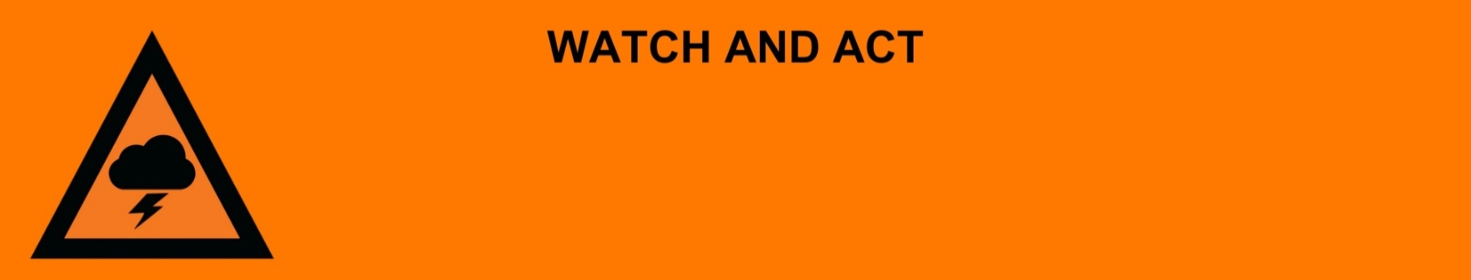

**Issued:** [time, day, date, year]

**Next update:** [time, day, date, year] or as the situation changes.

[Insert issuing agency] advises people in the following area(s):

* [Add location(s) here]

to **LIMIT TIME OUTSIDE** due toa [dangerous/severe] [dust storm/thunderstorm/severe weather] that is [approaching now/approaching very soon].

**For emergency help in floods and storms, call the QLD SES on 132 500 or download the SES Assistance QLD App. In life threatening situations, call Triple Zero (000) immediately.**

**What are we expecting?**

The Bureau of Meteorology advises [insert BOM prediction here, including time/when it’s expected to hit].

* Damaging hail.
* Very heavy rain making it dangerous to drive, flash flooding is possible.
* Dust storms with the potential to cause respiratory issues.
* Strong winds causing debris like fallen trees, powerlines could come down and the power could go out.

**What you need to do:**

* Find out how to get ready for severe weather at the [Get Ready Queensland website (Get Prepared).](https://www.getready.qld.gov.au/get-prepared)
* Close doors and windows and move or stay indoors clear of windows.
* If you must travel, consider the consequences of road conditions and closures, and make alternate arrangements for work, children, and travel.
* If your roof or house is struck by a fallen tree/branch or other large debris - stay clear and remain indoors if you can.
* Put your pets somewhere safe, ensure they can be easily identified if they get lost.
* If caught outdoors, shelter under sturdy cover away from trees, and power lines.
* Warn friends, family, and neighbors in the area.

**If you find it hard to move quickly or have special or medical needs:**

* Use your Person-Centred Emergency Plan (P-CEP) now if you have one.
* Make sure you have enough medicine for at least one week.
* If anyone in your house uses powered medical equipment, like a dialysis machine or ventilator, decide now where you will go in case you lose power.
* Call your support person or service to organise transport if you need to leave.

**If you are a tourist, visitor, camper or caravanner:**

* Campers and caravanners should remain inside your caravan or find building or structure that will protect you from the weather like a picnic shelter, amenities block or bridge.
* If you do not need to be in the warning area, leave now. Check road conditions and plan your route before you leave.
* Be ready to move if the situation gets worse.
* Ask the campground owners whether the site floods.
* Check your surroundings of water catchments, and monitor conditions.

**For more information:**

* Follow our local council disaster dashboard here [insert disaster dashboard link].
* Listen to your local radio [add ABC local radio or other station and frequency].
* For power outage information go to [energex.com.au](https://qldpolice.sharepoint.com/sites/EMC-PublicInfoWarnings-TQPS/Shared%20Documents/General/WARNINGS/Templates/NEW%20&%20IMPROVED%20TEMPLATES%20(SES%20INSPIRED)/Final%20Flood%20Templates%2012092024/energex.com.au) or [ergon.com.au/network](https://qldpolice.sharepoint.com/sites/EMC-PublicInfoWarnings-TQPS/Shared%20Documents/General/WARNINGS/Templates/NEW%20&%20IMPROVED%20TEMPLATES%20(SES%20INSPIRED)/Final%20Flood%20Templates%2012092024/ergon.com.au/network) [select energy provider].
* Check the latest weather, warnings, rainfall, and river heights at the [Bureau of Meteorology Queensland website.](http://www.bom.gov.au/qld/)