MOVE TO HIGHER GROUND
[Location]
Tropical Cyclone (Storm Surge)
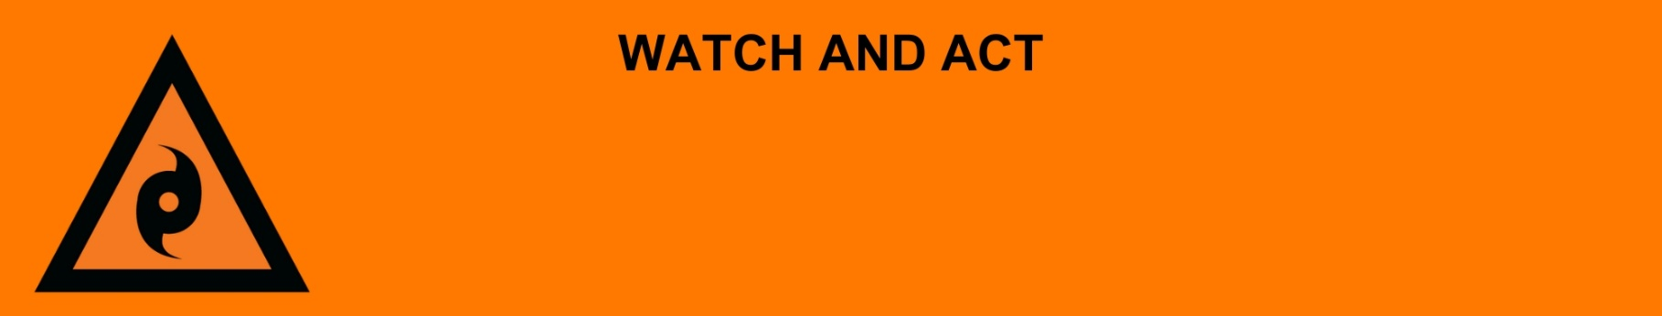
Issued: [time, day, date, year]
Next update: [time, day, date, year] or as the situation changes.

[Insert issuing agency] advises people in the following area(s):
- [Add location(s) here]

must MOVE TO HIGHER GROUND now. This could be with family or friends away from the storm surge areas. Tropical Cyclone [Name] is [going to cause / causing] a [widespread / localised / fast-moving / dangerous] storm surge. Storm surge is a rise in sea level over and above the normal tide levels because of a cyclone. Storm surge is a threat to life and property.
It will soon be too late to leave. People who find it hard to move quickly should leave immediately. An [evacuation centre/cyclone shelter] has been set up here (insert link/area)

For emergency help in floods and storms, call the QLD SES on 132 500 or download the SES Assistance QLD App. In life threatening situations, call Triple Zero (000) immediately.

What are we expecting?
The Bureau of Meteorology advises [insert BOM prediction here, including time/when it’s expected to hit/track map].
- There will be lots of wind and rain from the cyclone. There will be flooding in low-lying areas.

What you need to do:
Prepare your home:
- Put chemicals and poisons up high to stop them polluting the water.
- Lift important things onto bed, tables, shelves or upstairs to protect them.
- Use sandbags to block toilets, sinks and drains to stop sewerage backflow.
- Decide if you need to turn off the power, solar, water and gas before you leave.
- Move cars to high ground away from trees.
- Check your family, friends and neighbours know what to do. Help them if you can.

If you need to drive:
- Do not drive through floodwater. If the road is flooded, go a different way.
- Watch out for damaged roads, fallen trees or powerlines.

If you find it hard to move quickly or have special or medical needs:
- Use your Person-Centred Emergency Plan (P-CEP) now if you have one.
- Make sure you have enough medicine for at least one week.
- If anyone in your house uses powered medical equipment, like a dialysis machine or ventilator, decide now where you will go in case you lose power.
- Call your support person or service to organise transport if you need to leave.
- Leaving early is safer than waiting.

If you are a tourist, visitor, camper or caravanner:
- Campers and caravanners should start packing up now.
- If you do not need to be in the warning area, leave now. Check road conditions and plan your route before you leave.

For more information:
- Follow our local council disaster dashboard here [insert disaster dashboard link].
- Listen to your local radio [add ABC local radio or other station and frequency].
- For power outage information go to energex.com.au or ergon.com.au/network [select energy provider].
- Check the latest weather, warnings, rainfall, and river heights at the Bureau of Meteorology Queensland website.
- Information on what to do during a disaster visit the Get Ready Queensland website (During a Disaster).
- Check road closures at the QLD Traffic website or for phone service call 13 19 40.
- Check disruptions to public transport at the Translink website.

