Indigenous Business Month

October 2024

Acknowledgment of Country

We pay our respects to Aboriginal and Torres Strait Islander peoples of this land, their ancestors and their legacy. The foundations laid by the ancestors—First Nations Peoples—give strength, inspiration and courage to current and future generations to create a better Queensland.

We recognise it is our collective efforts and responsibility as individuals, communities and governments to ensure equity, recognition and advancement of Aboriginal and Torres Strait Islander Queenslanders across all aspects of society and everyday life.

We are committed to working with, representing, advocating for and promoting the needs of Aboriginal and Torres Strait Islander Queenslanders with unwavering determination, passion and persistence.

As we reflect on the past and hope for the future, we walk together on a shared journey and vision of reconciliation where all Queenslanders are equal and the diversity of Aboriginal and Torres Strait Islander cultures and communities across Queensland is recognised, respected and valued by all Queenslanders.



**Note for Queensland Government agencies – Caretaker arrangements**

From Tuesday 1 October 2024, the Queensland Government will assume caretaker mode. This will continue until results from the 26 October 2024 election are clear.

Departments that wish to promote Indigenous Business Month 2024 during the caretaker period should ensure they follow the [Guidelines on the Caretaker conventions](https://www.premiers.qld.gov.au/publications/categories/policies-and-codes/handbooks/cabinet-handbook/caretaker-arrangements.aspx).

If you need further guidance on whether an activity or promotion should continue in respect to the caretaker conventions, please address your queries through your department channels.

# About Indigenous Business Month 2024

Indigenous Business Month (IBM) is a nation-wide event held from 1–31 October each year, showcasing Aboriginal and Torres Strait Islander business leadership across Australia.

This year, the theme is ***Making our Mark***. In its 10th year, IBM marks a decade of demonstrating the impact of First Nations businesses and calls on everyone to reflect on the achievements of the Indigenous business sector.

The Queensland Government recognises the importance of economic prosperity for all Queenslanders and supports IBM as an opportunity to shine a light on First Nations businesses across Queensland.

This October we are celebrating the growing ranks of successful First Nations businesses across Queensland.

# Get involved – show your support

You can support Indigenous Business Month by:

* sharing this toolkit with your stakeholders
* hosting a special event or attending events in your local area
* sharing content in this kit on your channels to raise awareness throughout the month.

For more information visit <http://www.business.qld.gov.au/ibm>

# Key messages

* IndigenousBusiness Month is held across Australia during October each year to celebrate and showcase Aboriginal and Torres Strait Islander businesses and leadership across the country.
* ***Making our Mark*** is this year’s theme and marks a decade of demonstrating the impact of First Nations businesses. The theme calls on everyone to reflect on the achievements of the Indigenous business sector.
* The Queensland Government recognises the importance of economic prosperity for all Queenslanders and supports Indigenous Business Month as an opportunity to shine a light on Aboriginal and Torres Strait Islander owned businesses across Queensland.
* Aboriginal and Torres Strait Islander owned businesses are critical to local, regional and state economies.
* Queensland has a strong and diverse Aboriginal and Torres Strait Islander owned business sector with thriving businesses in all sectors – almost every facet of the supply chain is likely to be serviced by a First Nations business.
* Indigenous Business Month is an opportunity to get involved and help raise awareness of and showcase Aboriginal and Torres Strait Islander business in local community by participating or organizing an event during Indigenous Business Month.
* Help celebrate Indigenous Business Month by hosting or attending an event this October and build connections now for a thriving future.
* Register and attend events in your local area by visiting [business.qld.gov.au/ibm](http://www.business.qld.gov.au/ibm)and [indigenousbusinessmonth.com.au](https://www.indigenousbusinessmonth.com.au/)
* Consider engaging with Aboriginal and Torres Strait Islander owned businesses to increase your supply chain.
* You can find an Aboriginal or Torres Strait Islander owned business using Queensland’s [Black Business Finder](https://www.bbf.org.au/) and through [Supply Nation](https://supplynation.org.au/)– a database of verified First Nations businesses in Australia.
* Share your stories using #IndigenousBusinessMonth #IBM2024 #MakingOurMark

# Newsletter content

**Shine a light on Aboriginal and Torres Strait Islander owned businesses!**

Each October we celebrate and showcase Aboriginal and Torres Strait Islander businesses and leadership across the country through Indigenous Business Month.

***Making our Mark*** is this year’s theme. It marks a decade of demonstrating the impact of First Nations businesses and calls on everyone to reflect on the achievements of the Indigenous business sector.

Queensland’s strong and diverse Indigenous business sector is critical to local, regional and the State economies; the employment of Aboriginal and Torres Strait Islander peoples and creating a future where every Queenslander can thrive.

Through collaborative partnerships with Aboriginal and Torres Strait Islander owned businesses and industry stakeholders, Queensland continues to drive the growth of the sector and demand for goods and services from First Nations businesses.

Aboriginal or Torres Strait Islander owned businesses cover a vast range of products, services and locations – consider engaging an Indigenous business for your next purchase and to grow your supply chain.

You can find an Aboriginal or Torres Strait Islander owned business using Queensland’s [Black Business Finder](https://www.bbf.org.au/) and through [Supply Nation](https://supplynation.org.au/)– a database of verified First Nations businesses in Australia.

A range of events are being held to celebrate Indigenous Business Month.

To register or find events in your area visit, [business.qld.gov.au/ibm](https://aus01.safelinks.protection.outlook.com/?url=https%3A%2F%2Fwww.business.qld.gov.au%2Fibm&data=05%7C01%7CShona.Buchanan%40dsdsatsip.qld.gov.au%7C00959dd86b574c04bee108dbb8b2d1bf%7C95b907c2752b485088ad86939ce522f0%7C0%7C0%7C638306850391904945%7CUnknown%7CTWFpbGZsb3d8eyJWIjoiMC4wLjAwMDAiLCJQIjoiV2luMzIiLCJBTiI6Ik1haWwiLCJXVCI6Mn0%3D%7C3000%7C%7C%7C&sdata=PdjPwvKzXCuTeUfCRWDmgbIJ%2Bg3TOO4rmtfhL6FZP88%3D&reserved=0) and [indigenousbusinessmonth.com.au](https://www.indigenousbusinessmonth.com.au/)

# 

# Social Media content

Let us know you’ve shared by including the following hashtags #IndigenousBusinessMonth #IBM2024 #MakingOurMark and tagging us:

* Facebook: [**@businessqldgov**](https://www.facebook.com/businessqldgov) and [@deadlystories](https://www.facebook.com/deadlystories)

|  |  |
| --- | --- |
|  | It’s[Indigenous Business Month](http://www.indigenousbusinessmonth.com.au)**!**  For the month of October organisations and individuals across Australia will be hosting events and celebrating the growing number of successful Indigenous owned businesses.  ***Making our Mark*** is this year’s theme. It marks a decade of demonstrating the impact of First Nations businesses and calls on everyone to reflect on the achievements of the Indigenous business sector.  See what’s happening during #IBM2024 in Queensland or register your event by visiting [business.qld.gov.au/ibm](https://aus01.safelinks.protection.outlook.com/?url=https%3A%2F%2Fwww.business.qld.gov.au%2Fibm&data=05%7C01%7CShona.Buchanan%40dsdsatsip.qld.gov.au%7C00959dd86b574c04bee108dbb8b2d1bf%7C95b907c2752b485088ad86939ce522f0%7C0%7C0%7C638306850391904945%7CUnknown%7CTWFpbGZsb3d8eyJWIjoiMC4wLjAwMDAiLCJQIjoiV2luMzIiLCJBTiI6Ik1haWwiLCJXVCI6Mn0%3D%7C3000%7C%7C%7C&sdata=PdjPwvKzXCuTeUfCRWDmgbIJ%2Bg3TOO4rmtfhL6FZP88%3D&reserved=0) and [indigenousbusinessmonth.com.au](https://www.indigenousbusinessmonth.com.au/)  To find and support Queensland Aboriginal or Torres Strait Islander owned business check out Black Business Finder and Supply Nation  **👉**<https://www.bbf.org.au/>  **👉**<https://supplynation.org.au/>  #IndigenousBusinessMonth #IBM2024 #MakingOurMark |
|  | October is Indigenous Business Month!  ***Making our Mark*** is this year’s theme. It marks a decade of demonstrating the impact of First Nations businesses and calls on everyone to reflect on the achievements of the Indigenous business sector.  Queensland’s strong and diverse Indigenous business sector is critical to local, regional and the State economies; the employment of Aboriginal and Torres Strait Islander peoples and creating a future where every Queenslander can thrive.  Through collaborative partnerships with Aboriginal and Torres Strait Islander owned businesses and industry stakeholders, Queensland continues to drive the growth of the sector and demand for goods and services from First Nations businesses.  For more information and to get involved visit [www.business.qld.gov.au/ibm](http://www.business.qld.gov.au/ibm)  #IndigenousBusinessMonth #IBM2024 #MakingOurMark |
|  | During Indigenous Business Month, help us to celebrate the growing number of successful Indigenous owned businesses across Australia. Visit [**business.qld.gov.au/ibm**](https://aus01.safelinks.protection.outlook.com/?url=https%3A%2F%2Fwww.business.qld.gov.au%2Fibm&data=05%7C01%7CShona.Buchanan%40dsdsatsip.qld.gov.au%7C00959dd86b574c04bee108dbb8b2d1bf%7C95b907c2752b485088ad86939ce522f0%7C0%7C0%7C638306850391904945%7CUnknown%7CTWFpbGZsb3d8eyJWIjoiMC4wLjAwMDAiLCJQIjoiV2luMzIiLCJBTiI6Ik1haWwiLCJXVCI6Mn0%3D%7C3000%7C%7C%7C&sdata=PdjPwvKzXCuTeUfCRWDmgbIJ%2Bg3TOO4rmtfhL6FZP88%3D&reserved=0) |
|  | We’re a proud Indigenous small business and it's great to be a part of Indigenous Business Month celebrations this October!    We’d like to say thanks to our customers, suppliers and buyers for supporting us to make our business a success!    Check out what’s happening during #IBM2024 in Queensland at [business.qld.gov.au/ibm](https://www.business.qld.gov.au/IBM) |
|  | During Indigenous Business Month shine a light on the growing number of successful First Nations owned businesses across Australia. #IBM2024 |

# Resources

Resources including social media tiles, email signature blocks and online meeting backgrounds are available to download from the Indigenous Business Month website: <https://www.indigenousbusinessmonth.com.au/resources>

## Social media tiles

 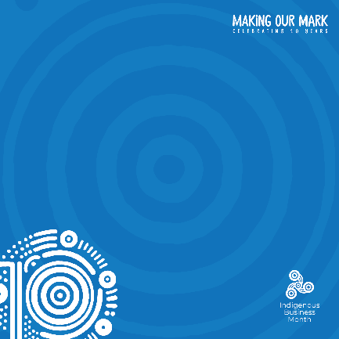 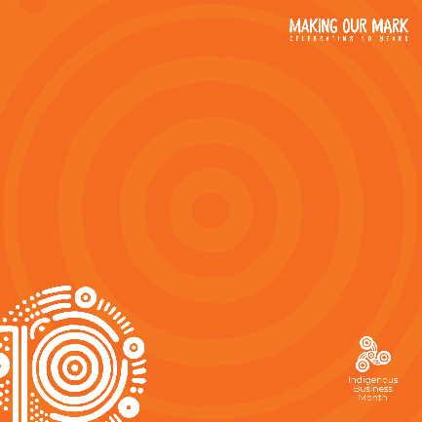

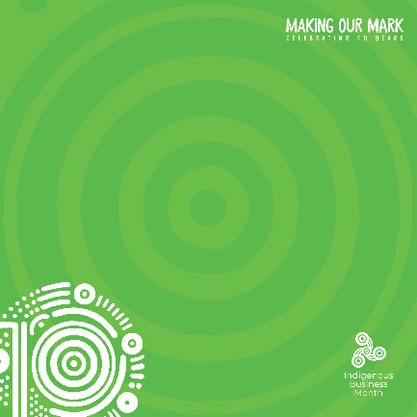

## Email signature block

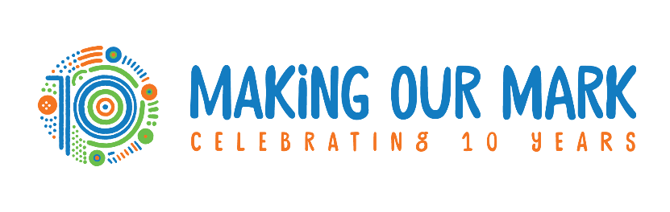

## Online meeting background

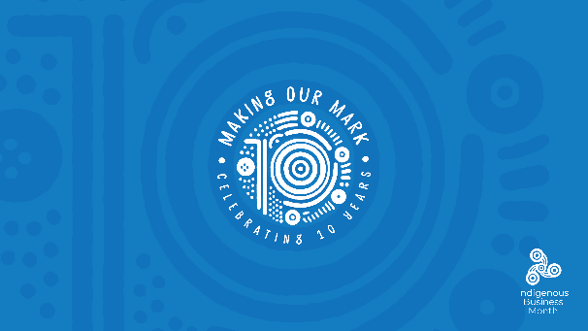 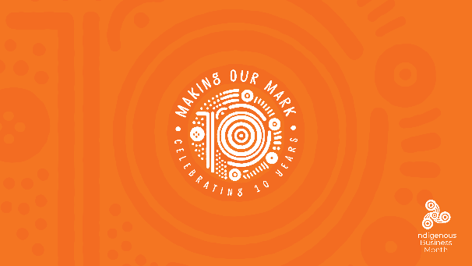

# Further information

For more information on Indigenous Business Month visit: [business.qld.gov.au/IBM](https://www.business.qld.gov.au/starting-business/advice-support/support/support-indigenous/ibm) and [indigenousbusinessmonth.com.au](https://www.indigenousbusinessmonth.com.au/)

For more information on First Nations business and economic development visit: [www.dsdsatsip.qld.gov.au/our-work/aboriginal-torres-strait-islander-partnerships/business-economic-development](http://www.dsdsatsip.qld.gov.au/our-work/aboriginal-torres-strait-islander-partnerships/business-economic-development)

Find an Aboriginal or Torres Strait Islander owned business using Queensland’s [Black Business Finder](https://www.bbf.org.au/) and through [Supply Nation](https://supplynation.org.au/)-- a database of verified Indigenous businesses in Australia.

Or contact Strategic Communication and Marketing  
Department of Treaty, Aboriginal and Torres Strait Islander Partnerships, Communities and the Arts

Email [campaigns@dsdsatsip.qld.gov.au](mailto:campaigns@dsdsatsip.qld.gov.au)