PREPARE NOW
[Location]
Flood (Descriptor)
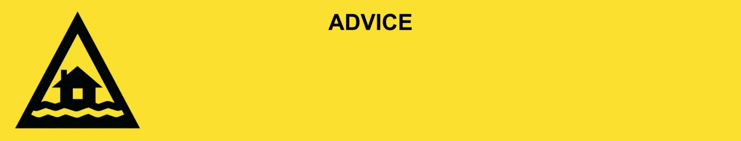
Issued: [time, day, date, year]
Next update: [time, day, date, year] or as the situation changes.

[Insert issuing agency] advises people in the following area(s):
- [Add location(s) here]

to PREPARE NOW for the [minor/moderate/major/flash] flooding on the [river/street/area name].

For emergency help in floods and storms, call the QLD SES on 132 500 or download the SES Assistance QLD App. In life threatening situations, call Triple Zero (000) immediately.

What are we expecting?
The Bureau of Meteorology advises [insert BOM prediction here, including time/when it’s expected to hit].
- Bridges and low lying roads may be impacted by floodwater.
- Transportation may be out of service.
- Once the floodwater reaches [X] metres, expected at [Time AM/PM today/tomorrow date], safe evacuation routes are likely to be cut off.
- You [may/will] become isolated until flood waters recede.

What you need to do:
- Find out how to get ready for a flood at the Get Ready Queensland website (Get Prepared).
- Never drive, walk, ride, play or swim in flood water. If it’s flooded, forget it.
- Decide if you and the people you live with will leave if floodwaters get close to your house.
- If you have children make sure they are with you or a responsible adult.
- Be prepared to have no power. Charge mobile phones and other electronic devices now.
- Get and fill sandbags in case you need to block doors and stop water getting inside. You can get sandbags from XX.
- Use sandbags to block toilets, sinks and drains to stop sewerage backflow.
- Tell friends, family, and neighbours in the area. Help others if you can.

If you decide to leave early:
- Lift important things onto bed, tables, shelves or upstairs to protect them.
- Lift waste containers, chemicals, and poisons up high.
- Pack enough clothes, food, water, medicine, baby items (like nappies, formula) and pet food for [three / five / other] days. Plan not to have a fridge or microwave.
- Take your pets, mobile phone charger, battery-powered radio, torch, and valuables like photos, cash, and important documents (like identification, insurance, or banking records).
- Lock windows and doors.
- Go to a safe place, away from flooding. This could be with family or a friend.
- If you come to a flooded road, turn around and go another way. Do not drive through floodwater.

If you find it hard to move quickly or have special or medical needs:
- Use your Person-Centred Emergency Plan (P-CEP) now if you have one.
- Make sure you have enough medicine for at least one week.
- If anyone in your house uses powered medical equipment, like a dialysis machine or ventilator, decide now where you will go in case you lose power.
- Call your support person or service to organise transport if you need to leave.
- Leaving early is safer than waiting.

If you are a tourist, visitor, camper or caravanner:
- Campers and caravanners should start packing up now.
- If you do not need to be in the warning area, leave now. Check road conditions and plan your route before you leave.
- Be ready to move if the situation gets worse.
- Ask the campground owners whether the site floods.
- Check your surroundings of water catchments, and monitor conditions.

For more information:
- Follow our local council disaster dashboard here [insert disaster dashboard link].
- Listen to your local radio [add ABC local radio or other station and frequency].
- For power outage information go to energex.com.au or ergon.com.au/network [select energy provider].
- Check the latest weather, warnings, rainfall, and river heights at the Bureau of Meteorology Queensland website.
- Check road closures at the QLD Traffic website or for phone service call 13 19 40.
- Check disruptions to public transport at the Translink website.

