PREPARE TO LEAVE
[Location]
Flood (Descriptor)
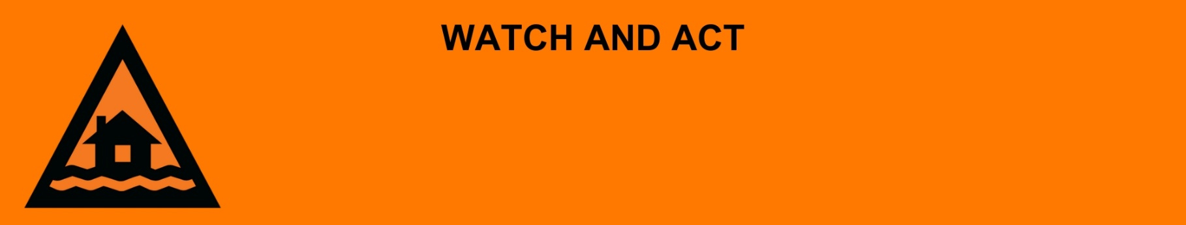
Issued: [time, day, date, year]
Next update: [time, day, date, year] or as the situation changes.

[Insert issuing agency] advises people in the following area(s):
- [Add location(s) here]

to PREPARE TO LEAVE by [time, date] due to the [minor/moderate/major/flash] flooding on the [river/street/area name]. An [evacuation centre/registration point/assembly area] has been set up here [insert link/area]

For emergency help in floods and storms, call the QLD SES on 132 500 or download the SES Assistance QLD App. In life threatening situations, call Triple Zero (000) immediately.

What are we expecting?
The Bureau of Meteorology advises
- Once the floodwater reaches [X] metres, expected at [Time AM/PM today/tomorrow date], safe evacuation routes are likely to be cut off.

What you need to do:
- Pack enough clothes, food, water, medicine, baby items (like nappies, formula) and pet food for [three / five / other] days. Plan not to have a fridge or microwave.
- Get ready to take your pets, mobile phone charger, battery-powered radio, torch, and valuables like photos, cash, and important documents (like identification, insurance, or banking records).
- If you have children make sure they are with you or a responsible adult.
- Lift important things onto bed, tables, shelves or upstairs to protect them.
- Decide where you and the people you live with will go. Go to a safe and high place, away from flooding.
- Decide how you will get to your safe place.
- If you come to a flooded road, turn around and go another way. Do not drive through floodwater.
- Warn friends, family, and neighbours in the area that a flood is coming.
- Help others to get ready to leave if you can.

If you find it hard to move quickly or have special or medical needs:
- Use your Person-Centred Emergency Plan (P-CEP) now if you have one.
- Make sure you have enough medicine for at least one week.
- If anyone in your house uses powered medical equipment, like a dialysis machine or ventilator, decide now where you will go in case you lose power.
- Call your support person or service to organise transport if you need to leave.
- Leaving early is safer than waiting.

If you are a tourist, visitor, camper or caravanner:
- Campers and caravanners should start packing up now.
- If you do not need to be in the warning area, leave now. Check road conditions and plan your route before you leave.
- Be ready to move if the situation gets worse.
- Ask the campground owners whether the site floods.
- Check your surroundings of water catchments, and monitor conditions.

For more information:
- Follow our local council disaster dashboard here [insert disaster dashboard link].Listen to your local radio [add ABC local radio or other station and frequency].
- For power outage information go to energex.com.au or ergon.com.au/network [select energy provider].
- Check the latest weather, warnings, rainfall, and river heights at the Bureau of Meteorology Queensland website.
- For information on what to do during a disaster visit the Get Ready Queensland website (During a Disaster).
- Check road closures at the QLD Traffic website or for phone service call 13 19 40.
- Check disruptions to public transport at the Translink website.

