RETURN WITH CAUTION
[Location]
Flood (Descriptor)
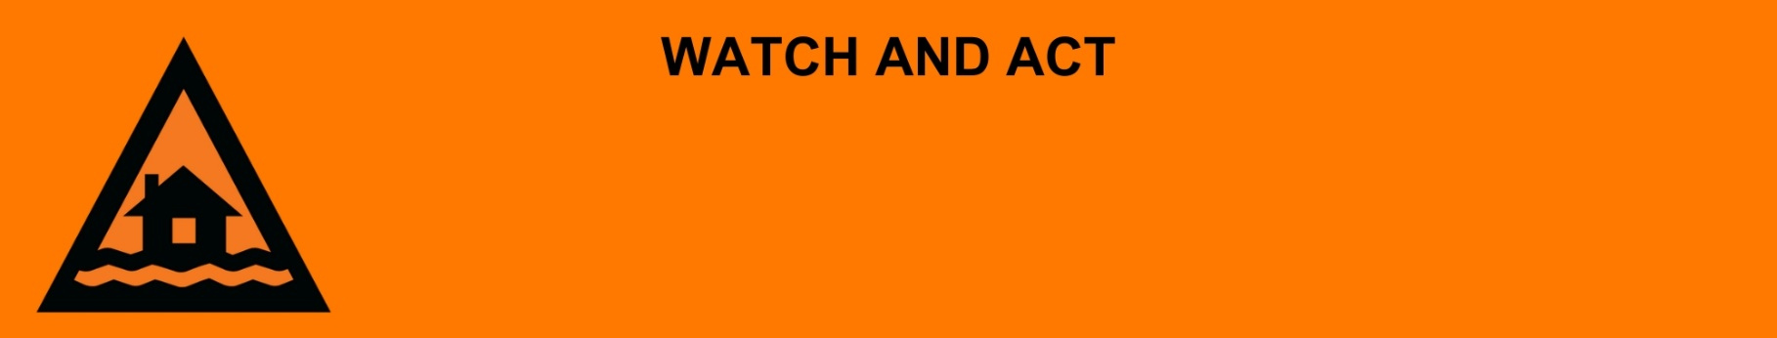
Issued: [time, day, date, year]
Next update: [time, day, date, year] or as the situation changes.

[Insert issuing agency] advises people in the following location(s):
- [Add location(s) here]

can RETURN WITH CAUTION due to the [minor/moderate/major/flash] flooding and damage to the area.

For emergency help in floods and storms, call the QLD SES on 132 500 or download the SES Assistance QLD App. In life threatening situations, call Triple Zero (000) immediately.

What are we expecting?
- Flood water is starting to go down, but it is still dangerous because [of dangerous, major, wide-spread, fast-moving and/or unpredictable flooding]
- There has been significant flood damage to infrastructure and dangerous hazards within the area.

What you need to do:
- If you evacuated, you may return if it is safe to do so.
- If you come to a flooded road, turn around and go another way. Do not drive through floodwater.
- Some places do not have clean water. Tap water is not safe to drink.
- Mobile phones and internet might not have service.
- Some places do not have power. There may also be electrical hazards.
- The number of mosquitos can grow after a flood. Protect your health and safety by using repellent, wear closed in shoes, long sleeves and pants, and empty containers that have water in them.

If your home or business has been flooded:
- Make sure your property is safe before entering. Check for damage to windows, walls and the roof and be careful of potential dangers including asbestos.
- Make sure the electricity and gas are turned off before going inside.
- If power points, electrical equipment, appliances or electrical hot water systems have been exposed to floodwater or are water damaged in any way, they must be inspected by a qualified electrician before use.
- Gas appliances and gas bottles that have been exposed to floodwater should be inspected for safety before use.
- Sandbags that have been in contact with floodwater need to be thrown away. Sturdy gloves should be worn when handling wet sandbags as they can contain chemicals, waste, and diseases from floodwater.
- Protect your health and safety; wear boots, gloves and protective clothing when cleaning up, wash your hands and clothes often, throw away food that should be kept cold or frozen if you lost power.
- If safe, clean, and dry out the building as soon as you can.

Support and recovery help:
- Go to [insert council name and website] for clean-up and recovery information.
- Recovery services are available [insert details of organisations actively involved; ideally on the ground]:
  - Agency – Location, full address and times.
- For general relief and recovery information go to the Get Ready Queensland website (After a Disaster).
- Natural disasters can affect your mental health. If you need help, call any of these groups:
  - Lifeline: Go to lifeline.org.au or phone 13 11 14.
  - Beyond Blue: Go to beyondblue.org.au or phone 1300 224 636.
  - Kids Helpline: Go to kidshelpline.com.au or phone 1800 551 800.

For more information:
- Follow our local council disaster dashboard here [insert disaster dashboard link].
- Listen to your local radio [add ABC local radio or other station and frequency].
- For power outage information go to energex.com.au or ergon.com.au/network [select energy provider].
- Check the latest weather, warnings, rainfall, and river heights at the Bureau of Meteorology Queensland website.
- Check road closures at the QLD Traffic website or for phone service call 13 19 40.
- Check disruptions to public transport at the Translink website.

