Promotional toolkit

# Indigenous Languages Grants 2025

Funding language initiatives across Queensland

Acknowledgment of Country

We pay our respects to the Aboriginal and Torres Strait Islander ancestors of this land, their spirits and their legacy. The foundations laid by these ancestors gives strength, inspiration and courage to current and future generations, towards creating a better Queensland.

# Overview

Queensland plays a significant role in preserving Australia’s First Nations languages, holding the nation’s second largest Aboriginal and Torres Strait Islander population.

More than 100 Aboriginal and Torres Strait Islander languages and dialects were once spoken in Queensland. Today, around 50 of these languages are still spoken with less than 20 used as a first language, predominantly in the north of the state and in the Torres Strait Islands.

The Indigenous Languages Grants support Queensland-based activities that contribute to the preservation and revival of Aboriginal and Torres Strait Islander languages.

Grants of up to $15,000 (exclusive of GST) per activity will be available for eligible organisations.

Applications close – 8am (AEST) Friday 27 June 2025.

# Help us spread the word

You can help us promote the Indigenous Languages Grants the by sharing this toolkit with your stakeholders and using the resources in this kit.

Resources include:

* Key messages
* Social media posts
* Newsletter and/or email content
* Social media tiles and images
* Further information.

## Key messages

* The Indigenous Languages Grants Program supports projects and cultural activities that preserve, maintain and promote Aboriginal and Torres Strait Islander languages.
* Grants of up to $15,000 (exclusive of GST) per activity are available for Queensland-based activities that support the preservation of Aboriginal and Torres Strait Islander languages.
* Indigenous Languages Grants are provided to activities that preserve Aboriginal and Torres Strait Islander languages in recognition of the role language plays in strengthening culture and community.
* A range of cultural initiatives incorporating Aboriginal and Torres Strait Islander languages may be eligible for an Indigenous Languages Grant, including art, drama, music and film projects, Yarning Circles, audio recordings, workshops, signage, books, posters and brochures.
* The total funding available in 2024-25 is $285,000.
* The Indigenous Languages Grants round closes at 8am Friday 27 June 2025.
* Further information and how to apply is available at [www.qld.gov.au/ilg](http://www.qld.gov.au/ilg).

**Key dates**

* Applications close – 8am (AEST) Friday 27 June 2025
* Announcement of recipients – 9 August 2025

## Social media posts

|  |  |
| --- | --- |
| **Timing** | **Message** |
|  | Applications for round five of the Queensland Government Indigenous Languages Grants are now open!  A range of cultural initiatives incorporating First Nations languages may be eligible for an Indigenous Languages Grant, including art, drama, music and film projects, Yarning Circles, audio recordings, workshops, signage, books, posters and brochures.  Grants of up to $15,000 (ex GST) are available for Queensland-based activities that support the preservation of Indigenous languages.  Applications close 8am, Friday 27 June 2025.  Read more about the grants and how to apply at [www.qld.gov.au/ilg](http://www.qld.gov.au/ilg) |
|  | Do you have a great idea for a project or initiative to preserve, maintain and promote Aboriginal and Torres Strait Islander languages? Queensland Government Indigenous Languages Grants of up to $15,000 (ex GST) are available for activities that preserve First Nations languages in recognition of the role language plays in strengthening culture and community.  Applications close 8am, Friday 27 June 2025.  Read more about the grants and how to apply at [www.qld.gov.au/ilg](http://www.qld.gov.au/ilg) |
| 2-3 weeks before applications close | There’s still time to apply for up to $15,000 (ex GST) of funding for Queensland-based activities that support the preservation of Indigenous languages under the Indigenous Languages Grants. Applications close 8am, Friday 27 June 2025.  Find out more and apply at [www.qld.gov.au/ilg](http://www.qld.gov.au/ilg) |

## Email and/or newsletter content

**Indigenous Languages Grants 2025 — now open**

Queensland-based projects and cultural activities that preserve, maintain and promote Aboriginal and Torres Strait Islander languages are invited to apply for an Indigenous Languages Grant.

Grants of up to $15,000 are available for activities that support the preservation of Aboriginal and Torres Strait Islander languages.

In Queensland, more than 100 Aboriginal and Torres Strait Islander languages and dialects were once spoken. Today around 50 of these remain, with less than 20 used as first languages.

The Queensland Government Indigenous Languages Grants program aims to preserve First Nations languages in recognition of the role language plays in strengthening culture and community.

A range of cultural activities may be eligible for an Indigenous Languages Grant, including art, drama, music and film projects, Yarning Circles, audio recordings, workshops, signage, books, posters and brochures.

Applications close 8am, Friday 27 June 2025. More information, including how to apply, is available at [www.qld.gov.au/ilg](http://www.qld.gov.au/ilg).

## Social media tiles and newsletter image

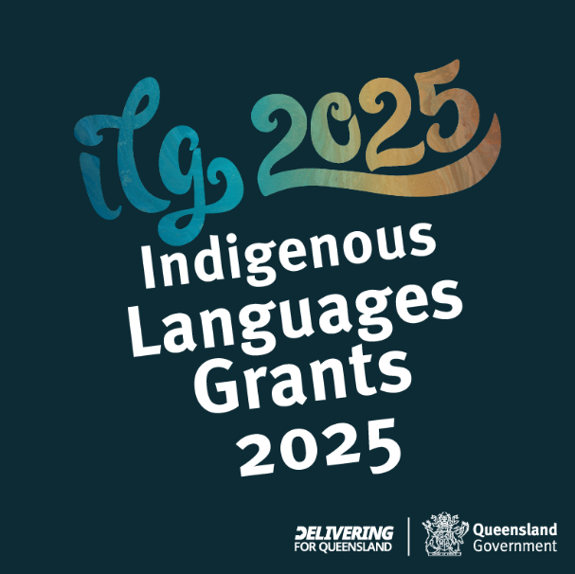 

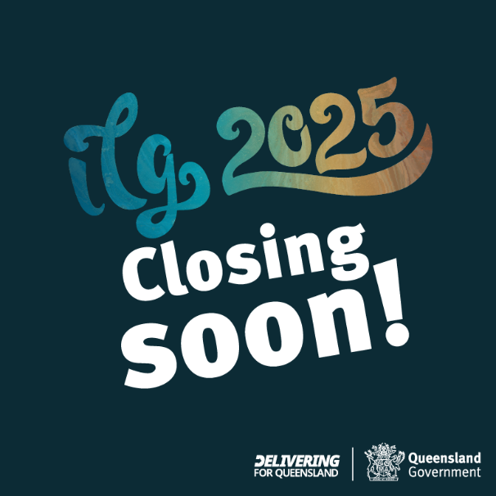

**Newsletter image**

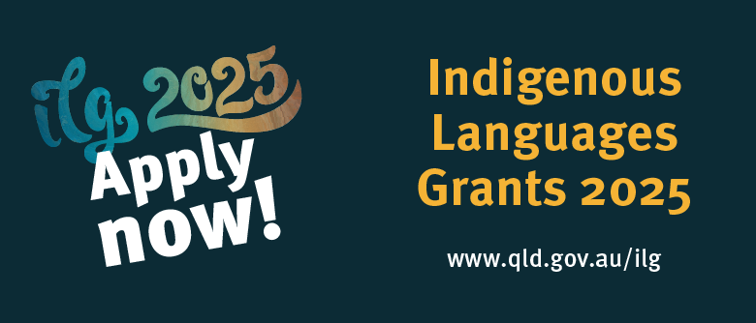

Download social media tiles and newsletter image here -[https://www.tatsipca.qld.gov.au/about/news-media/promotional-assets/](https://aus01.safelinks.protection.outlook.com/?url=https%3A%2F%2Fwww.tatsipca.qld.gov.au%2Fabout%2Fnews-media%2Fpromotional-assets%2F&data=05%7C02%7CSamantha.Hillman%40dsdsatsip.qld.gov.au%7Cd5f940565dbe48cd778808dda3ce96b1%7C95b907c2752b485088ad86939ce522f0%7C0%7C0%7C638846830191633081%7CUnknown%7CTWFpbGZsb3d8eyJFbXB0eU1hcGkiOnRydWUsIlYiOiIwLjAuMDAwMCIsIlAiOiJXaW4zMiIsIkFOIjoiTWFpbCIsIldUIjoyfQ%3D%3D%7C0%7C%7C%7C&sdata=dKQTCEi62ZLW%2BPOMExjpbCL%2FQp7%2B%2FHTJtuXLl5NL4Iw%3D&reserved=0)

# Further information

Strategic Communication and Marketing  
Governance and Strategic Communication  
Department of Treaty, Aboriginal and Torres Strait Islander Partnerships, Communities and the Arts

Email: [campaigns@dsdsatsip.qld.gov.au](mailto:campaigns@dsdsatsip.qld.gov.au)