ROYAL COMMISSION INTO NATIONAL NATURAL DISASTER ARRANGEMENTS

**QUEENSLAND GOVERNMENT’S SIXTH IMPLEMENTATION PROGRESS REPORT**

**JULY 2024**

2023-2024 saw Queensland experience multiple, overlapping disaster events, such as Cyclones Jasper, Kirrily and Lincoln in Far North Queensland, along with significant bushfires the length and breadth of the state. The scale and impact of these events has been wide reaching and has reinforced the Queensland Government’s commitment to ensuring we are best placed to deliver exceptional disaster and emergency management systems and services to Queenslanders. This includes the commitment to deliver on all 69 of the state supported recommendations from the Royal Commission into National Natural Disaster Arrangements (RCNNDA).

In the past six months the Queensland Government has made significant progress in delivering RCNNDA recommendations, with 42 of the recommendations relevant to Queensland now considered delivered.

Recommendations recently delivered include:

*Disaster management data coordination (recommendation 4.2)*

* The Queensland Government has delivered the Disaster Management Data Coordination Initiative which has enabled data sharing across all four phases of disaster management (prevention, preparedness, response and recovery). This initiative enables key stakeholders within the Queensland Disaster Management Arrangements from local, state and federal levels to collaborate and share disaster related information with the aim of improving Queensland’s ability to better plan, manage and respond to disaster events.

*Implementation of the Australian Warning System (recommendations 13.3, 13.4, 13.5, 13.6)*

* Queensland has implemented the Australian Warning System (AWS) in collaboration with partner agencies, across all five nationally agreed hazards. The AWS is a new national approach to information and warnings during emergencies. It provides a consistent, easier to follow and understand warning system across the country. During the 2023-24 higher risk weather season Queensland actively issued warnings for storm, flood, cyclone, heat and bushfire using the AWS messaging and iconography.

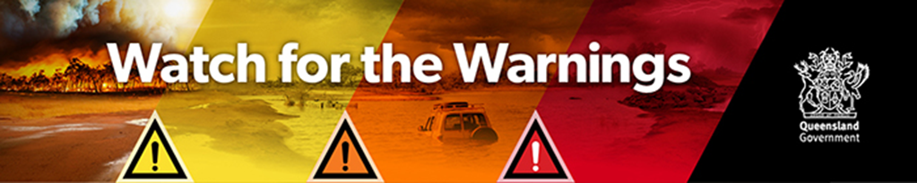

* The Queensland Fire Department (QFD) also led grass-roots community engagement and ran the Watch for Warnings media campaign, to support Queensland communities to understand the new AWS. Queensland is a state of extremes, and the scale and impact of disaster events can be wide reaching. The Queensland Government encourages everyone to “Watch for the Warnings” and know what is happening and what to do during hazards and emergencies. Information on the AWS in Queensland can be found on the [Queensland Fire Department website](https://www.fire.qld.gov.au/aws).

*Review of Disaster Recovery Funding Arrangements and the development of pre-agreed recovery programs (Recommendation 22.1, 22.5, 22.7, 22.8).*

* The Queensland Government has worked with the Australian, State and Territory Governments to review disaster recovery funding arrangements, evaluate funding effectiveness, and develop a range of guidelines for pre-arranged “off-the-shelf” recovery support programs. This has included guidelines for Category D Infrastructure Betterment Program, Category C/D Recovery Grants for Primary Producers and Category C/D Recovery Grants for Small Businesses and Non-Profit Organisations.
* Queensland leads the nation in building resilience in its communities through linking resilience measures into disaster recovery funding packages, ensuring they are embedded with flexibility, fit for place and purpose, and address the specific needs of the community. For example, the Queensland and Australian Governments developed the Resilient Homes Fund to help Queenslanders across 39 local government areas whose homes were impacted by the 2021-2022 floods. The aim of the program is to help as many Queenslanders as possible with the funding available, by providing resilient options through the Resilient Retrofit, Home Raising, and Voluntary Home Buy-Back programs.
* The Queensland Government, through the Queensland Reconstruction Authority (QRA), initiated the Queensland Betterment Funds. Betterment allows local governments and state agencies to rebuild essential public assets to a more resilient standard to help them withstand the impacts of future natural disasters. Successful betterment projects include improvements to vital infrastructure such as roads, bridges and floodways. Since 2013, more than 720 projects across 75 local government areas in Queensland – with a betterment value of approximately $533 million – have been approved, helping create stronger, more resilient Queensland communities.

Queensland is on track to deliver the remaining recommendations. The Queensland Government remains committed to minimising the impacts of disasters and ensuring Queensland communities are kept safe and supported.