RETURN WITH CAUTION
[Location]
Tropical Cyclone [Name]
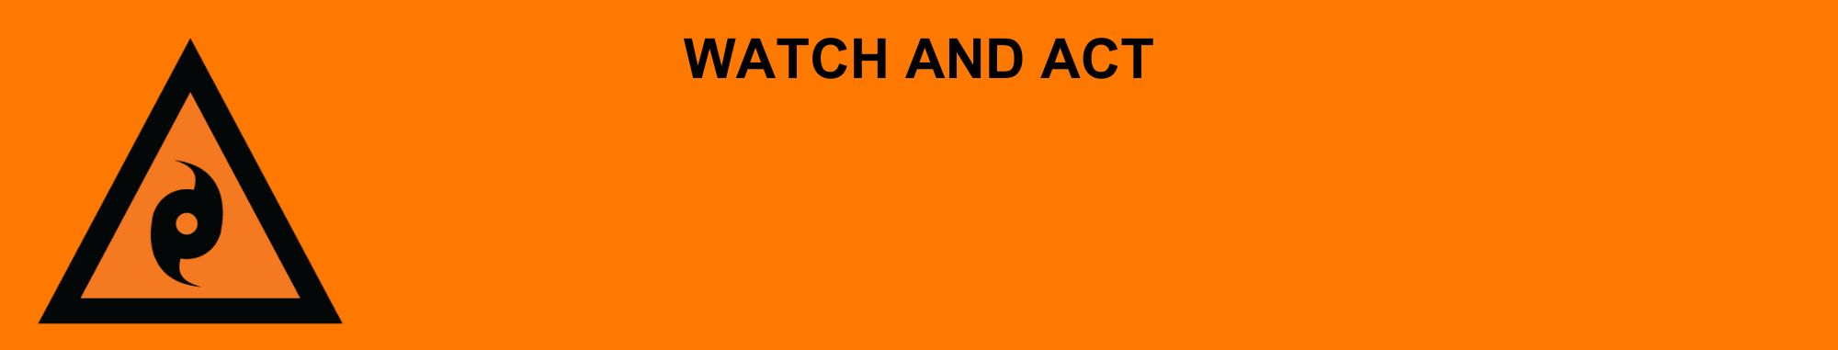
Issued: [time, day, date, year]
This is the last warning for this Tropical Cyclone. There could be other warnings for the area, stay up to date.

[Insert Issuing Agency] advises to RETURN WITH CAUTION in the following area(s):
- [Add location(s) here]

Tropical Cyclone [Name] has now passed. You still need to be careful of the dangers and damage caused by the cyclone.

What are we expecting?
- Powerlines and trees may have fallen. They can be hard to see and covered in debris.
- The power and phone services could be out for a long time. They will be restored when staff and supplies can get through, and when safe.
- Roads [are / may be] closed or badly damaged. Do not drive unless you have to.
- Water supply [might be / has been] impacted. Drink only water from your emergency supply.
- Flooding will start to go down. Never play, walk, ride or drive through flood water because it is dangerous. There could be [crocodiles, sharks, snakes] or raw sewerage.

What you need to do:
- Drive slowly if going back home, remain alert. Be aware of fallen powerlines, trees, and other hazards. Damage to roads and buildings caused by winds may still exist in your area.
- Water supply might be / has been impacted. Drink only water from your emergency supply.
- Check in on your neighbours, animals, and livestock if safe to do so.
- Stay away from flood waters.
- Protect your health and safety; wear boots, gloves and protective clothing when cleaning up, wash your hands and clothes often, throw away food that should be kept cold or frozen if you lost power.
- Do not go sight-seeing. Keep roads clear for emergency services.

If your property has been affected by the tropical cyclone:
- Make sure your property is safe before entering. Check for damage to windows, walls and the roof and be careful of potential dangers including asbestos.
- Make sure the electricity and gas are turned off before going inside. There could be gas leaks, never use naked flames inside.
- If power points, electrical equipment, appliances or electrical hot water systems have been exposed to water or are water damaged in any way, they must be inspected by a qualified electrician before use.
- Gas appliances and bottles that have been exposed to water or damaged should be inspected for safety before use.

Support and recovery help:
- Go to [insert council name and website] for clean-up and recovery information.
- Recovery services are available [insert details of organisations actively involved; ideally on the ground]:
  - Agency – Location, full address and times.
- For general relief and recovery information go to the Get Ready Queensland website (After a Disaster).
- Natural disasters can affect your mental health. If you need help, call any of these groups:
  - Lifeline: Go to lifeline.org.au or phone 13 11 14.
  - Beyond Blue: Go to beyondblue.org.au or phone 1300 224 636.
  - Kids Helpline: Go to kidshelpline.com.au or phone 1800 551 800.

For more information:
- Follow our local council disaster dashboard here [insert disaster dashboard link].
- Listen to your local radio [add ABC local radio or other station and frequency].
- For power outage information go to energex.com.au or ergon.com.au/network [select energy provider].
- Check the latest weather, warnings, rainfall, and river heights at the Bureau of Meteorology Queensland website.
- Check road closures at the QLD Traffic website or for phone service call 13 19 40.
- Check disruptions to public transport at the Translink website.

