PREPARE NOW
[Location]
Tropical Cyclone (Storm Surge)
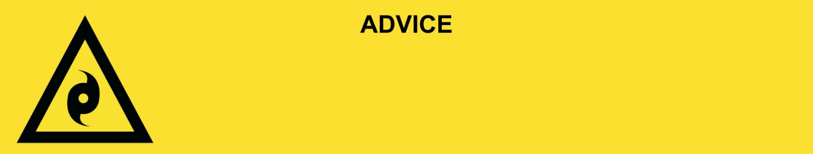
Issued: [time, day, date, year]
Next update: [time, day, date, year] or as the situation changes.

[Insert issuing agency] advises people in the following area(s):
- [Add location(s) here]

to PREPARE NOW for storm surge from Tropical Cyclone [Name] that is [forming off / stationary off / moving [slowly or quickly] towards] the Queensland coast. Storm surge is a rise in sea level over and above the normal tide levels because of a cyclone. Storm surge is a threat to life and property.

For emergency help in floods and storms, call the QLD SES on 132 500 or download the SES Assistance QLD App. In life threatening situations, call Triple Zero (000) immediately.

What are we expecting?
The Bureau of Meteorology advises [insert BOM prediction here, including time/when it’s expected to hit/track map].
- Waves and sea water will travel a long way inland and through coastal creeks and rivers. This can flood and damage buildings, wash away roads and cars, and damage bridges.
- Roads could be blocked by fallen trees, powerlines, or flood water from the cyclone.
- There will be lots of wind and rain from the cyclone. There will be flooding in low-lying areas.
- Power, water, phone, and sewerage services could stop working.

What you need to do:
- If you have children make sure they are with you or an adult you trust.
- Prepare your home now:
  - Put chemicals and poisons up high to stop them polluting the water.
  - Lift important things onto bed, tables, shelves or upstairs to protect them.
  - Use sandbags to block toilets, sinks and drains to stop sewerage backflow.
  - Find out how to safely turn off the power, solar, water and gas.
  - Move cars to high ground away from trees.
- Check your family, friends and neighbours know what to do. Help them if you can.

If you find it hard to move quickly or have special or medical needs:
- Use your Person-Centred Emergency Plan (P-CEP) now if you have one.
- Make sure you have enough medicine for at least one week.
- If anyone in your house uses powered medical equipment, like a dialysis machine or ventilator, decide now where you will go in case you lose power.
- Call your support person or service to organise transport if you need to leave.
- Leaving early is safer than waiting.

If you are a tourist, visitor, camper or caravanner:
- Campers and caravanners should start packing up now.
- If you do not need to be in the warning area, leave now. Check road conditions and plan your route before you leave.
- Be ready to move if the situation gets worse.
- Ask the campground owners whether the site is affected by storm surge.
- Check your surroundings of water catchments, and monitor conditions.

For more information:
- Follow our local council disaster dashboard here [insert disaster dashboard link].
- Listen to your local radio [add ABC local radio or other station and frequency].
- For power outage information go to energex.com.au or ergon.com.au/network [select energy provider].
- Check the latest weather, warnings, rainfall, and river heights at the Bureau of Meteorology Queensland website.
- Check road closures at the QLD Traffic website or for phone service call 13 19 40.
- Check disruptions to public transport at the Translink website.

