AVOID THE AREA
[Location]
Tropical Cyclone [Name]
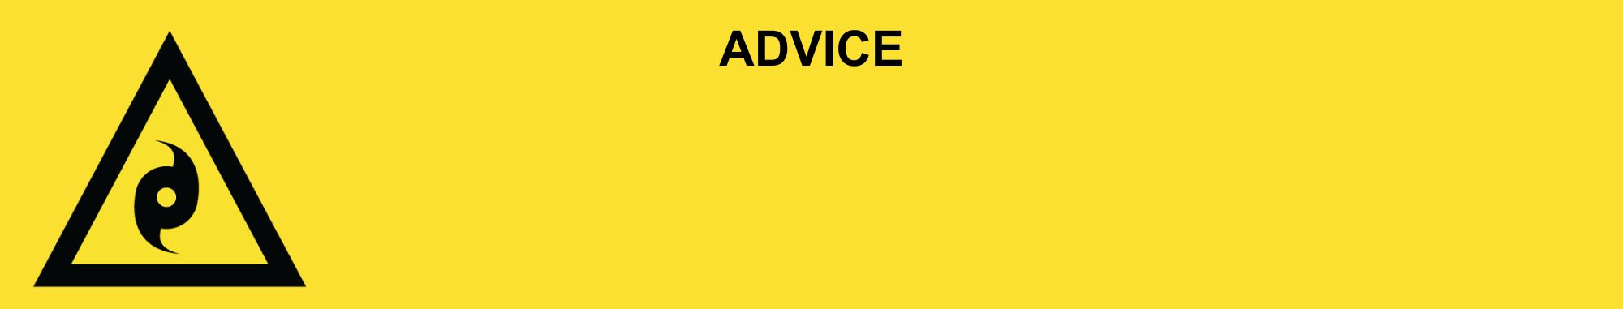
Issued: [time, day, date, year]
Next update: [time, day, date, year] or as the situation changes.

[Insert Issuing Agency] advises to AVOID THE AREA in the following area(s):
- [Add location(s) here]

Tropical Cyclone [Name] [has now passed / is currently passing / predicted to pass at TIME.] You still need to be careful of the dangers and possible damages of the cyclone.

For emergency help in floods and storms, call the QLD SES on 132 500 or download the SES Assistance QLD App. In life threatening situations, call Triple Zero (000) immediately.

What are we expecting?
- Powerlines and trees may have fallen. They can be hard to see when covered in debris.
- The power and phone services [might be / has been] impacted. They will be restored when staff and supplies can get through, and when safe.
- Roads [are / may be] closed or badly damaged.
- Water supply [might be / has been] impacted. Drink only water from your emergency supply.
- There could be [crocodiles, sharks, snakes] or raw sewerage.
- Heat and humidity often follow tropical cyclones.

What you need to do:
- Avoid returning to homes or businesses due to [damage / possible damage.] If you choose to return, drive slowly and remain alert. Be aware of fallen powerlines, trees, and other hazards.
- Power is off in some places. These will be restored when it is safe.
- Do not go sight-seeing. Keep roads clear for emergency services.

Support and recovery help:
- Go to [insert council name and website] for clean-up and recovery information.
- Recovery services are available [insert details of organisations actively involved; ideally on the ground]:
  - Agency – Location, full address and times.
- For general relief and recovery information go to the Get Ready Queensland website (After a Disaster).
- Natural disasters can affect your mental health. If you need help, call any of these groups:
  - Lifeline: Go to lifeline.org.au or phone 13 11 14.
  - Beyond Blue: Go to beyondblue.org.au or phone 1300 224 636.
  - Kids Helpline: Go to kidshelpline.com.au or phone 1800 551 800.

For more information:
- Follow our local council disaster dashboard here [insert disaster dashboard link].
- Listen to your local radio [add ABC local radio or other station and frequency].
- For power outage information go to energex.com.au or ergon.com.au/network [select energy provider].
- Check the latest weather, warnings, rainfall, and river heights at the Bureau of Meteorology Queensland website.
- Check road closures at the QLD Traffic website or for phone service call 13 19 40.
- Check disruptions to public transport at the Translink website.

