PREPARE NOW
[Location]
Tropical Cyclone [Name]
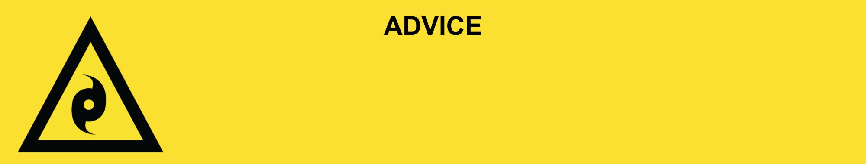
Issued: [time, day, date, year]
Next update: [time, day, date, year] or as the situation changes.

[Insert issuing agency] advises people in the following area(s):
- [Add location(s) here]

to PREPARE NOW for Tropical Cyclone [Name] that is [forming off / stationary off / moving [slowly or quickly] towards] the Queensland coast. An [evacuation centre/cyclone shelter] has been set up here (insert link/area).

For emergency help in floods and storms, call the QLD SES on 132 500 or download the SES Assistance QLD App. In life threatening situations, call Triple Zero (000) immediately.

What are we expecting?
The Bureau of Meteorology advises [insert BOM prediction here, including time/when it’s expected to hit/track map].
The tropical cyclone could cross the coast [near location / between location 1 and 2] by [tomorrow / day of the week e.g., Monday]. Conditions will get worse as it gets closer to land.

What you need to do:
Check or make an emergency kit:
- Find out how to get ready for a tropical cyclone and pack an emergency kit at the Get Ready Queensland website (Get Prepared).
- Fill up containers and the bath with clean water for drinking in case the water supply is cut off.

Prepare your property:
- Fill your car with fuel or charge it. Park it undercover. Do not park under a tree.
- Put away or tie down outside items like furniture, gas bottles, and play equipment.
- If your home is not safe, plan to stay with family or friends.
- If you are near the beach or a coastal waterway, storm surge could cause flooding. This is dangerous. Decide now where you will evacuate to.
- Close cyclone shutters if you have them, or cover windows with plywood, mattress, or heavy blanket.
- Find out how to safely turn off power, solar, water, and gas to your house. Be ready to turn it off if told to.
- Check your family, friends and neighbours know what to do. Help them if you can.

If you find it hard to move quickly or have special or medical needs:
- Use your Person-Centred Emergency Plan (P-CEP) now if you have one.
- Make sure you have enough medicine for at least one week. If anyone in your house uses powered medical equipment, like a dialysis machine or ventilator, decide now where you will go in case you lose power.
- Call your support person or service to organise transport if you need to leave.
- Leaving early is safer than waiting.

If you are a tourist, visitor, camper or caravanner:
- Campers and caravanners should start packing up now.
- If you do not need to be in the warning area, leave now. Check road conditions and plan your route before you leave.
- If you stay, ask accommodation staff where to shelter if the cyclone comes.

For more information:
- Follow our local council disaster dashboard here [insert disaster dashboard link].
- Listen to your local radio [add ABC local radio or other station and frequency].
- For power outage information go to energex.com.au or ergon.com.au/network [select energy provider].
- Check the latest weather, warnings, rainfall, and river heights at the Bureau of Meteorology Queensland website.
- Check road closures at the QLD Traffic website or for phone service call 13 19 40.
- Check disruptions to public transport at the Translink website.

