NOT SAFE TO RETURN
[Location]
Tropical Cyclone [Name]
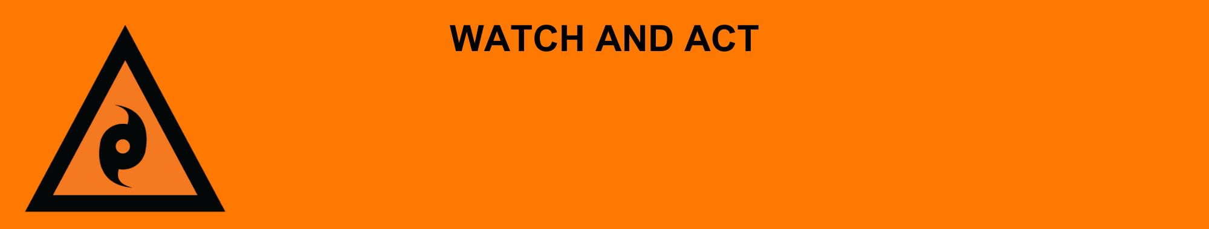
Issued: [time, day, date, year]
Next update: [time, day, date, year] or as the situation changes.

[Insert issuing agency] advises people it is NOT SAFE TO RETURN in the following area(s):
- [Add location(s) here]

Tropical Cyclone [Name] [has now passed / is currently passing.] You still need to be careful of the dangers and possible damages of the cyclone.

If your life is in danger, call Triple Zero (000) immediately.

What are we expecting?
The Bureau of Meteorology advises [insert BOM prediction here, including time/when it’s expected to hit/track map].

What are we expecting?
- If you left, stay where you are until you are told it safe to go back.
- Powerlines and trees have fallen. They can be hard to see when covered in debris.
- The power and phone services [might be / has been] impacted.
- Roads [are / may be] closed or badly damaged.
- Water supply [might be / has been] impacted. Drink only water from your emergency supply.
- Flooding will start to go down. Flood waters may rise. Never play, walk, ride or drive through flood water because it is dangerous. There could be [crocodiles, sharks, snakes] or raw sewerage.

What you need to do:
- Avoid returning to homes or businesses due to [damage / possible damage]. If you choose to return, drive slowly and remain alert. Be aware of fallen powerlines, trees, and other hazards.
- Do not use gas or generators inside. Fumes can be deadly.
- Protect your health and safety; wear boots, gloves and protective clothing when cleaning up, wash your hands and clothes often, throw away food that should be kept cold or frozen if you lost power.
- Do not go sight-seeing. Keep roads clear for emergency services.

Support and recovery help:
- For flood emergency help, call the SES on 132 500 or download the SES Assistance Queensland app.
- Go to [insert council name and website] for clean-up and recovery information.
- Recovery services are available [insert details of organisations actively involved; ideally on the ground]:
  - Agency – Location, full address and times.
- For general relief and recovery information go to the Get Ready Queensland website (After a Disaster).
- Natural disasters can affect your mental health. If you need help, call any of these groups:
  - Lifeline: Go to lifeline.org.au or phone 13 11 14.
  - Beyond Blue: Go to beyondblue.org.au or phone 1300 224 636.
  - Kids Helpline: Go to kidshelpline.com.au or phone 1800 551 800.
For more information:
- Follow our local council disaster dashboard here [insert disaster dashboard link]
- Listen to your local radio [add ABC local radio station and frequency]
- Find out what to do during a cyclone visit the Get Ready Queensland website (During a Disaster).
- For power outage information go to energex.com.au or ergon.com.au/network [select energy provider].
- Check the latest weather, warnings, rainfall, and river heights at the Bureau of Meteorology Queensland website.
- For emergency help in floods and storms, call the QLD SES on 132 500 or download the SES Assistance QLD App.
- Check road closures at the QLD Traffic website or for phone service call 13 19 40.
- Check disruptions to public transport at the Translink website.

