AVOID THE AREA
[Location]
Tropical Cyclone (Storm Surge)
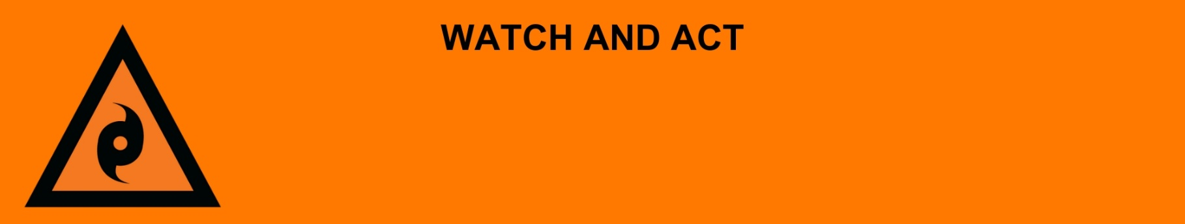
Issued: [time, day, date, year]
Next update: [time, day, date, year] or as the situation changes.

[Insert issuing agency] advises people in the following location(s):
- [Add location(s) here]

to AVOID THE AREA due to the [minor/moderate/major] storm surge and damage to the area.

For emergency help in floods and storms, call the QLD SES on 132 500 or download the SES Assistance QLD App. In life threatening situations, call Triple Zero (000) immediately.

What are we expecting?
The Bureau of Meteorology advises [insert BOM prediction here, including time/when it’s expected to hit]
- Flood water is starting to go down, but it is still dangerous because [of dangerous, major, wide-spread, fast-moving and/or unpredictable flooding]
- There has been significant flood damage to infrastructure and dangerous hazards within the area.

What you need to do:
- If you evacuated, stay where you are until you are told it safe to go back.
- If you did not leave, stay in your safe place until flood waters go down.
- If you have children make sure they are with you or an adult you trust.
- Some places do not have clean water. Tap water is not safe to drink.
- Mobile phones and internet might not work.
- Some places do not have power. There may also be electrical hazards.
- The number of mosquitos can grow after a flood. Protect your health and safety by using repellent, wear closed in shoes, long sleeves and pants, and empty containers that have water in them.
- Share this information with family, friends, and neighbors where possible.

Support and recovery help:
- Go to [insert council name and website] for clean-up and recovery information.
- Recovery services are available [insert details of organisations actively involved; ideally on the ground]:
  - Agency – Location, full address and times.
- For general relief and recovery information go to the Get Ready Queensland website (After a Disaster).
- Natural disasters can affect your mental health. If you need help, call any of these groups:
  - Lifeline: Go to lifeline.org.au or phone 13 11 14.
  - Beyond Blue: Go to beyondblue.org.au or phone 1300 224 636.
  - Kids Helpline: Go to kidshelpline.com.au or phone 1800 551 800.

For more information:
- Follow our local council disaster dashboard here [insert disaster dashboard link].
- Listen to your local radio [add ABC local radio or other station and frequency].
- For power outage information go to energex.com.au or ergon.com.au/network [select energy provider].
- Check the latest weather, warnings, rainfall, and river heights at the Bureau of Meteorology Queensland website.
- Check road closures at the QLD Traffic website or for phone service call 13 19 40.
- Check disruptions to public transport at the Translink website.

