Consultation open
Draft new Queensland Waste Strategy – Less landfill, more recycling
Stakeholder amplification pack

Background
On 1 May 2025, we started consultation on the draft new Queensland Waste Strategy 2025-2030 – Less landfill, more recycling.

How you can help
We are seeking your support to raise awareness about the consultation within your networks.
This amplification pack includes messages and creative assets that you can use across your channels to encourage participation in the consultation.
Creative assets can be downloaded from our consultation Resources page.
We are promoting the consultation in our own channels including our EnvironmentQLD Facebook account – you may wish to follow, like, comment on or share our posts.
Our audiences are Queenslanders, industry and local government.
If you have any questions or would like more information, please contact OCE.policy@detsi.qld.gov

Key messages
- Queensland is working to reduce the amount of waste going to landfill each year.
- To achieve this, we need a strategy that clearly outlines practical action for reducing waste, boosting recycling and supporting jobs.
- Queenslanders are invited to have their say on the draft new Queensland Waste Strategy 2025-2030 – Less landfill, more recycling.
- The draft new waste strategy sets the strategic framework for boosting the economy and reducing the impact of waste on the environment through better management of waste products and materials.
- For more information visit Draft new Queensland Waste Strategy 2025–2030 consultation | Environment, land and water | Queensland Government
- Consultation closes at 5pm on 26 June.

Social media
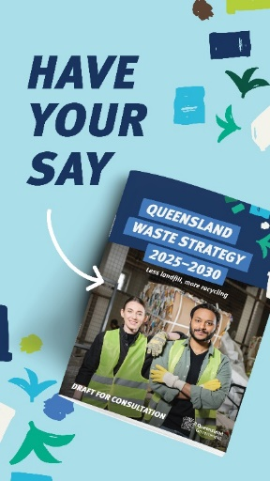  Instagram story tile (1080x1920px) | 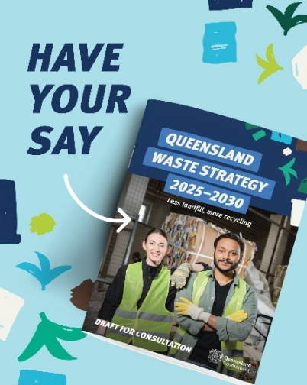  Instagram and Facebook tile (1080x1350px) | 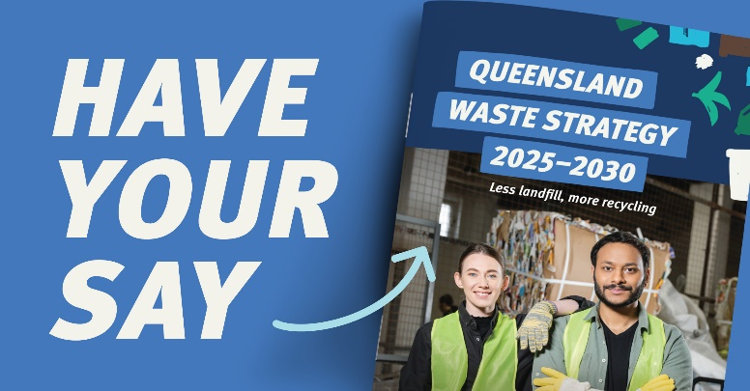  LinkedIn tile (1200x627px)
Social media post
Help shape the future of waste in Queensland and have your say on the draft new Queensland Waste Strategy. The strategy sets out how we can:
Reduce waste
Boost recycling
Support jobs to protect our environment
Support our economy
Visit the Queensland Government website for more information or search Qld Waste Strategy consultation.

Web, newsletters, emails
You can also add content and/or graphics to your website, newsletter or emails to let people know about the consultation.
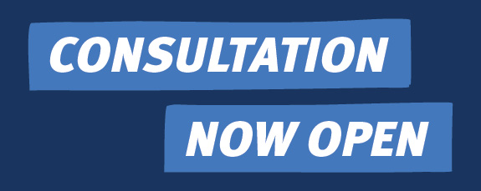  Web, newsletter, email consultation now open (276x110 pixels) | 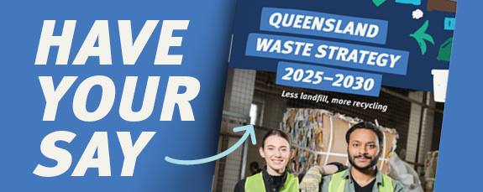  Web, newsletter, email Have your say (276x1102px)
  Web, newsletter, email feature image (1188x750 pixels) | 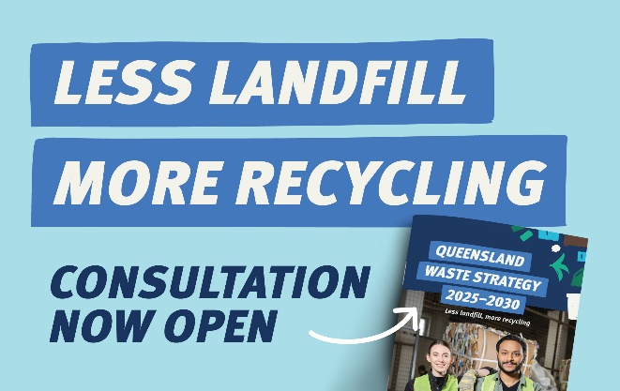  Web, newsletter, email) Less landfill, more recycling, consultation now open (1188x750 pixels)

Web and newsletter content (short and long options)
Draft new Queensland Waste Strategy 2025-20230 consultation
Find out how to have your say.

Have your say on the draft new Queensland Waste Strategy 2025–2030
Queensland is working towards a future with less landfill and more recycling.
To achieve this, we need a strategy that clearly outlines practical action for reducing waste, boosting recycling and supporting jobs.
The Queensland Government is seeking feedback on the draft new Queensland Waste Strategy 2025-2030 – Less landfill, more recycling.
Feedback on the draft strategy is critical to ensure practical measures boost recycling and reduce impacts to the environment without adding costs to businesses and Queenslanders.
Consultation is open until 5pm on 26 June.
Visit the Queensland Government website for more information.

