TAKE SHELTER NOW
[Location]
Tropical Cyclone [Name]
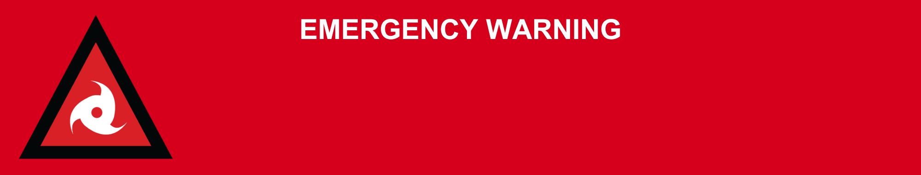
Issued: [time, day, date, year]
Next update: [time, day, date, year] or as the situation changes.

[Insert issuing agency] advises for people in the following area(s):
- [Add location(s) here]

to TAKE SHELTER NOW from Tropical Cyclone [insert name]. Tropical Cyclone [Name] [is crossing / is about to cross / will soon cross] the coast [at / near] [location].

People in [location] must TAKE SHELTER NOW. Go to the strongest, safest part of the building you are in. This will be away from big windows. It could be a bathroom, walk-in wardrobe, or hallway. Stay there.

In life threatening situations, call Triple Zero (000) immediately. Emergency services may not be able to get you because it is too dangerous.

What are we expecting?
The Bureau of Meteorology advises [insert BOM prediction here, including time/when it’s expected to hit/track map].
- The wind is very dangerous and will be very loud.
- You will hear things breaking outside and hitting your house.
- Winds could stop suddenly if the eye of the tropical cyclone goes over. Very dangerous winds could start again quickly from a different direction.
- Very strong winds can knock down trees and powerlines, blow roofs off houses, and blow away anything not tied down outside. This is a risk to life.
- Power, phone, and internet will stop working. They could be out for a long time.

What you need to do:
- Cover any windows in your safe room with a mattress or heavy blankets. This could protect you if the window breaks. Keep all doors and windows closed.
- If the roof comes off, shelter under your mattress and blankets.
- Stay in your safe place until you are told it is safe. This could take several hours.
- Keep pets in a safe place inside.
- Do not use generators inside. Fumes can be deadly.
- Limit use of devices to save batteries. Listen to local radio for updates.

For more information:
- Follow our local council disaster dashboard here [insert disaster dashboard link].
- Listen to your local radio [add ABC local radio or other station and frequency].
- For power outage information go to energex.com.au or ergon.com.au/network [select energy provider].
- Check the latest weather, warnings, rainfall, and river heights at the Bureau of Meteorology Queensland website.
- Check road closures at the QLD Traffic website or for phone service call 13 19 40.
- Check disruptions to public transport at the Translink website.

