Event Host Guide   
2025 Celebrating Reconciliation Grants program

May 2025

# Welcome

Congratulations on receiving funding from the Queensland Government’s Celebrating Reconciliation Grants Program for your reconciliation event in 2025.

National Reconciliation Week (27 May–3 June) provides a great opportunity for all Australians to learn about our shared histories, cultures and achievements.

National Reconciliation Week commemorates two significant milestones in the reconciliation journey—the successful 1967 referendum to change how Aboriginal and Torres Strait Islander peoples were referred to in the Constitution (27 May), and the 1992 High Court Mabo decision  
(3 June).

As part of Queensland National Reconciliation Week commemorations, the Celebrating Reconciliation Grants Program is providing funding for you to host your reconciliation event during May or June.

This guide contains information to assist you in planning and hosting your event to celebrate National Reconciliation Week, including:

* tips for hosting your event
* how to promote your event
* information about how to engage with local media
* style basics for using the materials supplied with this guide

You will also be provided with some templates and images to help promote your event.

Thank you for your commitment to National Reconciliation Week and your contribution to achieving reconciliation in Queensland.

# Tips for hosting your event

Helpful tips for hosting your reconciliation event

* Create a **free**, interesting, informative and enjoyable event for your local community.
* Promote your event using the materials provided with this guide. You might choose to promote your event online using your website or social media channels, or simply by putting up posters and sharing information in your local community.
* Take a look at Reconciliation Australia’s website [www.reconciliation.org.au](http://www.reconciliation.org.au) for information and resources about National Reconciliation Week to help raise awareness at your event. You may also wish to incorporate the 2025 National Reconciliation Week theme into your event.
* Spread the word! Encourage your local community to get involved and visit [qld.gov.au/recgrants](https://iDOCS.ebus.root.internal/otcsdav/nodes/107995247/recgrants_) for more information about the program.
* Take lots of photos and tell us about your event (see ‘Promoting your event’).

# How to promote your event

Don’t forget to promote your event with your local community and networks to get as many people involved as possible. Consider some interesting channels you might use to reach your audience such as emails, meetings, newsletters and online channels (your website or social media). Think about the unique aspects of your event and promote these to your community.

## Key messages

We’ve provided key messages below to include in materials you develop to promote your event:

* National Reconciliation Week is a national campaign, held annually from 27 May to 3 June.
* We all have a role to play when it comes to reconciliation, and in playing our part we collectively build relationships and communities that value Aboriginal and Torres Strait Islander peoples, histories, cultures, and futures.
* Reconciliation is a journey for all Australians – as individuals, families, communities, organisations and importantly, as a nation. At the heart of this journey are relationships between the broader Australian community and Aboriginal and Torres Strait Islander peoples.
* National Reconciliation Week also commemorates two significant milestones in the reconciliation journey; the successful 1967 referendum and the High Court Mabo decision.
* The week is an opportunity for all Australians to learn about our shared histories, cultures and achievements and to explore how each of us can join the national reconciliation effort.
* Reconciliation must live in the hearts, minds and actions of all Australians as we move forward, creating a nation strengthened by respectful relationships between the wider Australian community and Aboriginal and Torres Strait Islander peoples.
* Reconciliation is a holistic, everyday approach that encompasses rights as well as symbolic and practical actions. National Reconciliation Week is an opportunity to highlight the relationship between Aboriginal peoples, Torres Strait Islander peoples and non-Indigenous Australians and open up a national debate on prejudice, discrimination and racism.

For more information about National Reconciliation Week, visit [www.reconciliation.org.au/national-reconciliation-week](https://www.reconciliation.org.au/national-reconciliation-week/)

To find out more about the Celebrating Reconciliation Grants Program, visit [www.qld.gov.au/recgrants](http://www.qld.gov.au/recgrants)

## Posting on social media

### Sample posts

We’ve included a couple of sample Facebook posts below to make it easier to promote your event. You may wish to adjust these posts to match your event and your social media voice. Please tag us in your posts! – [@deadlystories](https://www.facebook.com/deadlystories)

**Example 1:**

Today we’re coming together to celebrate reconciliation thanks to the Queensland Government’s Celebrating Reconciliation Grants program. Come along and learn about our shared histories, cultures and achievements and to explore how each of us can join the national reconciliation effort. Check out @deadlystories for other supported events across Queensland. #NRW2025

**Supporting image:**

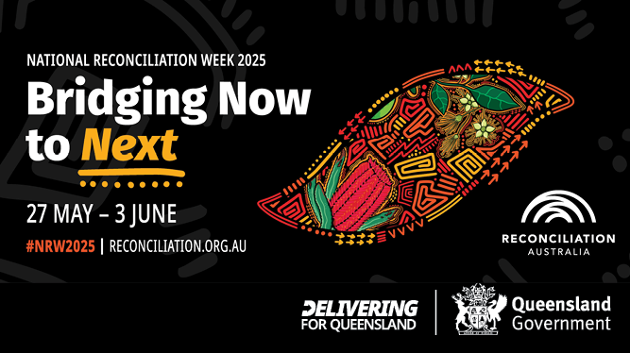

**Example 2:**

Today we’re celebrating reconciliation thanks to the Queensland Government’s Celebrating Reconciliation Grants program. Come along and share in the spirit of reconciliation. Check out @deadlystories for other supported events across Queensland. #NRW20253

**Supporting image:**

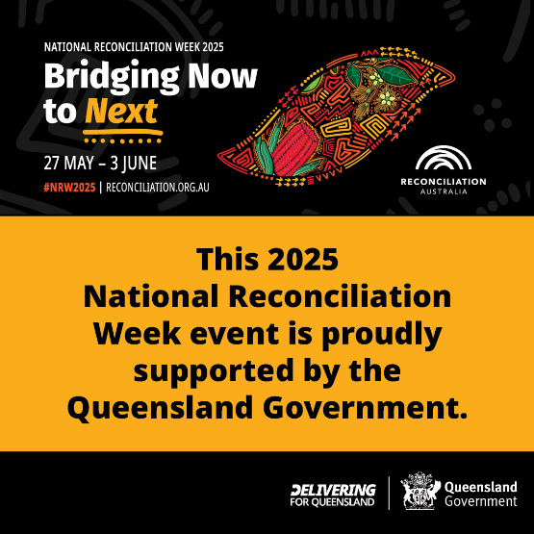

**You can also follow us at:**

[facebook.com/deadlystories](https://www.facebook.com/deadlystories)

C:\Users\smcdonou\AppData\Local\Microsoft\Windows\INetCache\Content.Word\In-2C-28px-R.PNG[linkedin.com/company/dsdsatsip](https://www.linkedin.com/company/datsip)

# 

# Capturing great photos at your event

When taking photos at your event think about how they might be used including:

* through your organisation’s website, social media, newsletters
* on the Queensland Government’s websites, social media, newsletters, etc., or
* in local media.

If you’re planning to publish your photos on a range of channels, it’s a good idea to capture several shots for each scene in both portrait and landscape view to ensure you have a few choices after your event is over.

We’ve included some tips below for taking better photographs at events.

## Tips for taking better photographs

* Make the most of natural lighting – make sure the sun is behind you but not in your subjects’ eyes
* If your event is at night, choose a well-lit spot or use your flash setting
* Ensure photos are well-framed – avoid blurry, dark or wide shots where possible
* Get up close if you are taking a photo of a single person or a small group
* Take multiple photos (both portrait and landscape) so you have options to choose from
* Take plenty of photos of guest speakers/performers throughout their speech or performance
* For posed group shots ensure everyone is looking at the camera
* Take a mix of posed and candid photos so you have plenty of choice afterwards
* Think about what’s in the background of your photo (avoid taking photos with windows, garbage bins, people eating, busy wallpaper, etc. in the background).

We’d love to share photographs of your reconciliation event and high-quality photos will ensure they can be used to showcase your event across all available channels.

However, photos will need to be high quality, so please ensure you send through the original photograph.

You can find more handy tips for taking photos on your phone at [www.abc.net.au/life/tips-for-taking-better-photos-on-your-phone/10329388](https://www.abc.net.au/life/tips-for-taking-better-photos-on-your-phone/10329388).

If you have any questions about providing photographs to the department, please contact our Communication team via email at [communications@dsdsatsip.qld.gov.au](mailto:communications@dsdsatsip.qld.gov.au).

## Getting consent to use photographs/video

It’s important to ensure you get consent from all of the people in all of the photographs/video you take at your event, particularly where they contain people under 18 years of age.

### Queensland Government consent form

The Queensland Government [consent form](https://www.dsdsatsip.qld.gov.au/about-us/news-media/film-photo-consent-form) is available online and can also be [downloaded](https://www.tatsipca.qld.gov.au/_media/documents/about/news-and-media/film-photo-consent.docx) and printed ahead of time. This consent form not only provides consent for a photo to be taken, it also outlines how and where it will be used and any considerations that need to be identified for privacy, cultural or personal reasons.

Please ask each individual photographed to complete this form. Forms for children under 18 years of age must be completed and signed by a parent or legal guardian.

Often, it’s easier to get consent immediately rather than trying to seek it later. Please send completed consent forms and your photos with your grant acquittal form.

## Consent to use someone else’s photo

Photos and imagery (artistic works) are subject to copyright, which means you need to ask the owner of the photo for their permission/consent to use and reproduce it.

Even if a photo is in print/on a website in the public domain, you must have approval from the owner if you would like the department to reproduce and distribute it as part of our materials.

**Get approval to use in writing**

It’s important to ask for this approval, and get it in writing, before providing any photos to the Department of Women, Aboriginal and Torres Strait Islander Partnerships, and Multiculturalism. The owner of the photo may want to be acknowledged so be sure to ask for any additional information they wish to include (location, date, photographer’s name etc.).

Getting this approval is critical as subjects may have passed away or may not have given permission for other organisations to use their photo. Approval not only covers the department but also gives the recognition legally required in this area.

Further information on photography copyright can be found at [www.copyright.org.au/ACC_Prod/ACC/Information_Sheets/Photographers___Copyright.aspx](http://www.copyright.org.au/ACC_Prod/ACC/Information_Sheets/Photographers___Copyright.aspx)

# Acknowledging your grant

The Queensland Government crest (logo) must be included in all marketing/promotional materials for your grant-funded event. A text acknowledgement of support should also be included where appropriate.

Please also include the following wording on your social posts, posters, flyers and websites:

***This initiative is proudly supported by the Queensland Government through the Celebrating Reconciliation Grants Program.***

The logo has been provided in EPS format (for design programs) and GIF format (for Microsoft Office programs).

The logo needs to be a minimum of 20mm high and preferred placement is to the bottom right hand side of the marketing material/s or digital platform/s. Please also ensure 5mm ‘clear space’ around the logo.

# Promotional resources

We have created the following resources to help you promote your event. Samples are included below, however, these files will be provided along with this guide.

**Social Media badge**

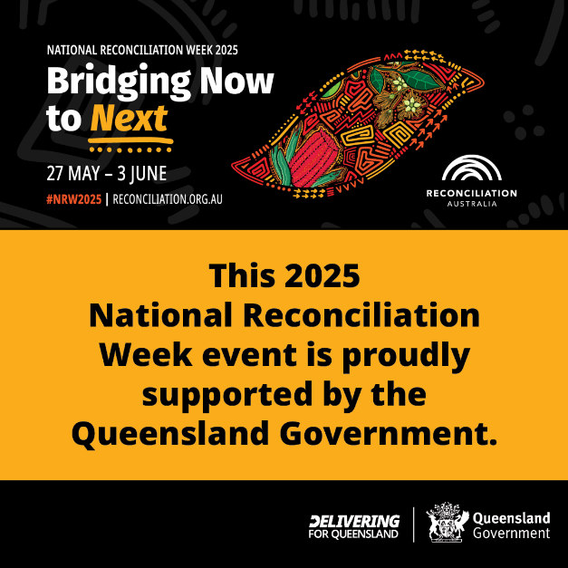

**Poster**

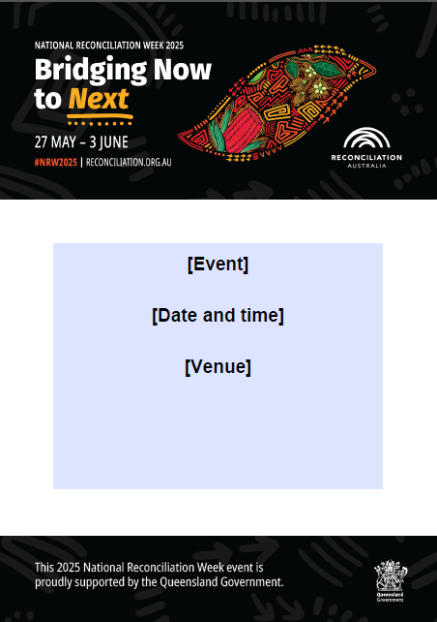

**Social / Web graphic**



## More information

For more information about hosting an event, please contact the Department of Women, Aboriginal and Torres Strait Islander Partnerships, and Multiculturalism Communication team via email at [communications@dsdsatsip.qld.gov.au](mailto:communications@dsdsatsip.qld.gov.au).