AVOID THE AREA
[Location]
Tropical Cyclone (Storm Surge)
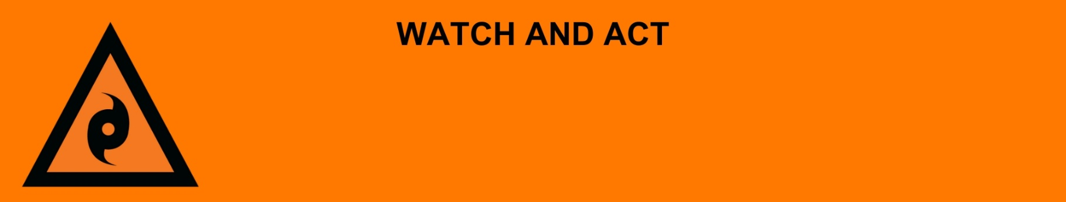
Issued: [time, day, date, year]
Next update: [time, day, date, year] or as the situation changes.

[Insert issuing agency] advises people in the following location(s):
- [Add location(s) here]

to AVOID THE AREA due to the [minor/moderate/major] storm surge and damage to the area.

For non-life-threatening flood and storm emergency assistance, contact SES on 132500, 132500.qld.gov.au, or the SES Assistance Qld app on Android or iOS. In a life-threatening situation, call Triple Zero (000) immediately.

What are we expecting?
The Bureau of Meteorology advises [insert BOM prediction here, including time/when it’s expected to hit]
- Flood water is starting to go down, but it is still dangerous because [of dangerous, major, wide-spread, fast-moving and/or unpredictable flooding]
- There has been significant flood damage to infrastructure and dangerous hazards within the area.

What you need to do:
- If you evacuated, stay where you are until you are told it safe to go back.
- If you did not leave, stay in your safe place until flood waters go down.
- If you have children make sure they are with you or an adult you trust.
- Some places do not have clean water. Tap water is not safe to drink.
- Mobile phones and internet might not work.
- Some places do not have power. There may also be electrical hazards.
- The number of mosquitos can grow after a flood. Protect your health and safety by using repellent, wear closed in shoes, long sleeves and pants, and empty containers that have water in them.
- Share this information with family, friends, and neighbors where possible.

Support and recovery help:
- Go to [insert council name and website] for clean-up and recovery information.
- Recovery services are available [insert details of organisations actively involved; ideally on the ground]:
  - Agency – Location, full address and times.
- For general relief and recovery information go to the Get Ready Queensland website (After a Disaster).
- Natural disasters can affect your mental health. If you need help, call any of these groups:
  - Lifeline: Go to lifeline.org.au or phone 13 11 14.
  - Beyond Blue: Go to beyondblue.org.au or phone 1300 224 636.
  - Kids Helpline: Go to kidshelpline.com.au or phone 1800 551 800.

For more information:
- Follow our local council disaster dashboard here [insert disaster dashboard link].
- Listen to your local radio [add ABC local radio or other station and frequency].
- For power outage information go to energex.com.au or ergon.com.au/network [select energy provider].
- Check the latest weather, warnings, rainfall, and river heights at the Bureau of Meteorology Queensland website.
- Check road closures at the QLD Traffic website or for phone service call 13 19 40.
- Check disruptions to public transport at the Translink website.

