PREPARE TO LEAVE
[Location]
Flood (Descriptor)
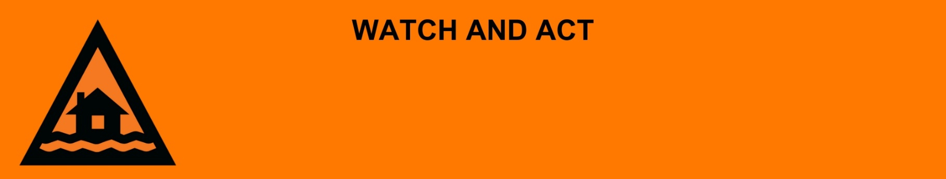
Issued: [time, day, date, year]
Next update: [time, day, date, year] or as the situation changes.

[Insert issuing agency] advises people in the following area(s):
- [Add location(s) here]

to PREPARE TO LEAVE by [time, date] due to the [minor/moderate/major/flash] flooding on the [river/street/area name]. An [evacuation centre/registration point/assembly area] has been set up here [insert link/area]

For non-life-threatening flood and storm emergency assistance, contact SES on 132500, 132500.qld.gov.au, or the SES Assistance Qld app on Android or iOS. In a life-threatening situation, call Triple Zero (000) immediately.

What are we expecting?
The Bureau of Meteorology advises
- Once the floodwater reaches [X] metres, expected at [Time AM/PM today/tomorrow date], safe evacuation routes are likely to be cut off.

What you need to do:
- Pack enough clothes, food, water, medicine, baby items (like nappies, formula) and pet food for [three / five / other] days. Plan not to have a fridge or microwave.
- Get ready to take your pets, mobile phone charger, battery-powered radio, torch, and valuables like photos, cash, and important documents (like identification, insurance, or banking records).
- If you have children make sure they are with you or a responsible adult.
- Lift important things onto bed, tables, shelves or upstairs to protect them.
- Decide where you and the people you live with will go. Go to a safe and high place, away from flooding.
- Decide how you will get to your safe place.
- If you come to a flooded road, turn around and go another way. Do not drive through floodwater.
- Warn friends, family, and neighbours in the area that a flood is coming.
- Help others to get ready to leave if you can.

If you find it hard to move quickly or have special or medical needs:
- Use your Person-Centred Emergency Plan (P-CEP) now if you have one.
- Make sure you have enough medicine for at least one week.
- If anyone in your house uses powered medical equipment, like a dialysis machine or ventilator, decide now where you will go in case you lose power.
- Call your support person or service to organise transport if you need to leave.
- Leaving early is safer than waiting.

If you are a tourist, visitor, camper or caravanner:
- Campers and caravanners should start packing up now.
- If you do not need to be in the warning area, leave now. Check road conditions and plan your route before you leave.
- Be ready to move if the situation gets worse.
- Ask the campground owners whether the site floods.
- Check your surroundings of water catchments, and monitor conditions.

For more information:
- Follow our local council disaster dashboard here [insert disaster dashboard link].
- Listen to your local radio [add ABC local radio or other station and frequency].
- For power outage information go to energex.com.au or ergon.com.au/network [select energy provider].
- Check the latest weather, warnings, rainfall, and river heights at the Bureau of Meteorology Queensland website.
- For information on what to do during a disaster visit the Get Ready Queensland website (During a Disaster).
- Check road closures at the QLD Traffic website or for phone service call 13 19 40.
- Check disruptions to public transport at the Translink website.

