AVOID THE AREA
[Location]
Tropical Cyclone (Storm Surge)
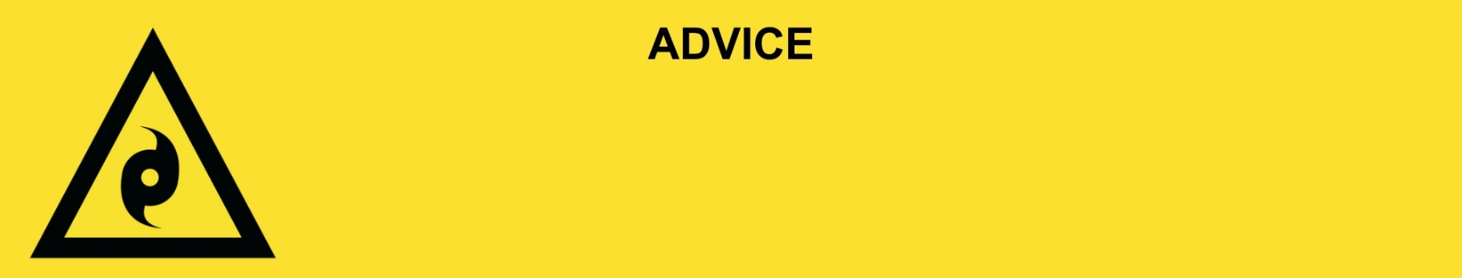
Issued: [time, day, date, year]
This will be the last warning issued for this storm surge in [location].

[Insert Issuing Agency] advises the following area(s):
- [Add location(s) here]

to AVOID THE AREA. You should stay away from the area as storm surge damage can be widespread.

What we are expecting:
- Roads and buildings have been badly damaged.
- Power and water are off in some places. These will be restored when it is safe.
- There is a lot of mud and rubbish on the ground and in the water.
- There could be more snakes, spiders, and rats inside.

What you need to do:
- If you evacuated, stay where you are until you are told it safe to go back.
- If you did not leave, stay in your safe place until flood waters go down.
- If you have children make sure they are with you or an adult you trust.
- Stay away from the impacted area.
- Some places do not have clean water. Tap water is not safe to drink.
- Mobile phones and internet might not work.
- Some places do not have power. There may also be electrical hazards.
- The number of mosquitos can grow after a flood. Protect your health and safety by using repellent, wear closed in shoes, long sleeves and pants, and empty containers that have water in them.
- Share this information with family, friends, and neighbors where possible.

Support and recovery help:
- Go to [insert council name and website] for clean-up and recovery information.
- Recovery services are available [insert details of organisations actively involved; ideally on the ground]:
  - Agency – Location, full address and times.
- For general relief and recovery information go to the Get Ready Queensland website (After a Disaster).
- Natural disasters can affect your mental health. If you need help, call any of these groups:
  - Lifeline: Go to lifeline.org.au or phone 13 11 14.
  - Beyond Blue: Go to beyondblue.org.au or phone 1300 224 636.
  - Kids Helpline: Go to kidshelpline.com.au or phone 1800 551 800.

For more information:
- Follow our local council disaster dashboard here [insert disaster dashboard link].
- Listen to your local radio [add ABC local radio or other station and frequency].
- For power outage information go to energex.com.au or ergon.com.au/network [select energy provider].
- Check the latest weather, warnings, rainfall, and river heights at the Bureau of Meteorology Queensland website.
- Check road closures at the QLD Traffic website or for phone service call 13 19 40.
- Check disruptions to public transport at the Translink website.

