STAY INFORMED
[Location]
Flood (Descriptor)
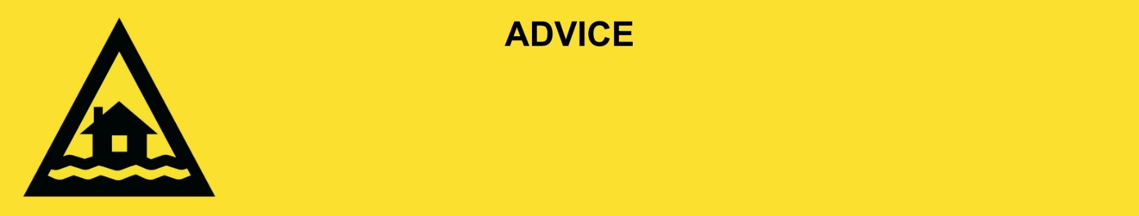
Issued: [time, day, date, year]
Next update: [time, day, date, year] or as the situation changes.

[Insert issuing agency] advises people in the following locations(s):
- [Add location(s) here]

to STAY INFORMED of the [minor/moderate/major/flash] flooding on the [river/street/area name].

For non-life-threatening flood and storm emergency assistance, contact SES on 132500, 132500.qld.gov.au, or the SES Assistance Qld app on Android or iOS. In a life-threatening situation, call Triple Zero (000) immediately.

What are we expecting?
The Bureau of Meteorology advises [insert BOM prediction here, including time/when it’s expected to hit].
- Bridges and low lying roads may be impacted by floodwater.
- Transportation may be out of service.
- Once the floodwater reaches [X] metres, expected at [Time AM/PM today/tomorrow date], safe evacuation routes are likely to be cut off.
- You [may/will] become isolated until flood waters recede.

What you need to do:
- Find out how to get ready for a flood at the Get Ready Queensland website (Get Prepared).
- Never drive, walk, ride through, play or swim in flood water. If it’s flooded, forget it.
- Consider the consequences of road and bridge closures. Damage to roads, bridges or buildings caused by flooding and landslip may exist in your area. Consider the need to make alternate arrangements for work, children, and travel.
- Drive to conditions and remain alert. Be aware of road hazards including mud, debris, and water in low lying areas.
- Obey all signs about road closures and instructions from emergency services.
- Get and fill sandbags in case you need to block doors and stop water getting inside. You can get sandbags from XX.
- Use sandbags to block toilets, sinks and drains to stop sewerage backflow.
- Tell friends, family, and neighbours in the area.

If you find it hard to move quickly or have special or medical needs:
- Use your Person-Centred Emergency Plan (P-CEP) now if you have one.
- Make sure you have enough medicine for at least one week.
- If anyone in your house uses powered medical equipment, like a dialysis machine or ventilator, decide now where you will go in case you lose power.
- Call your support person or service to organise transport if you need to leave.
- Leaving early is safer than waiting.

If you are a tourist, visitor, camper or caravanner:
- Campers and caravanners should start packing up now.
- If you do not need to be in the warning area, leave now. Check road conditions and plan your route before you leave.
- Be ready to move if the situation gets worse.
- Ask the campground owners whether the site floods.
- Check your surroundings of water catchments, and monitor conditions.

For more information:
- Follow our local council disaster dashboard here [insert disaster dashboard link].
- Listen to your local radio [add ABC local radio or other station and frequency].
- For power outage information go to energex.com.au or ergon.com.au/network [select energy provider].
- Check the latest weather, warnings, rainfall, and river heights at the Bureau of Meteorology Queensland website.
- Check road closures at the QLD Traffic website or for phone service call 13 19 40.
- Check disruptions to public transport at the Translink website.

