|  |
| --- |
| **AVOID THE AREA** |
|  |
| **[Location]** |
| **Severe Weather (Descriptor)** |

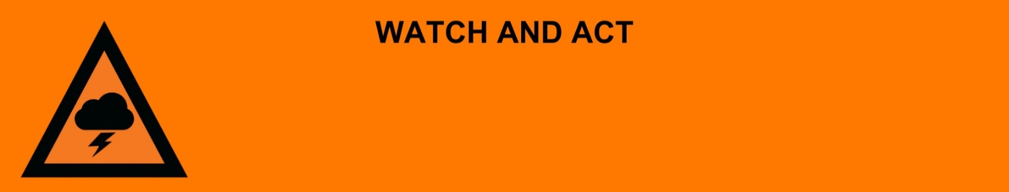

**Issued:** [time, day, date, year]

**Next update:** [time, day, date, year] or as the situation changes.

[Insert issuing agency] advises people:

* [Add location(s) here]

to **AVOID THE AREA** in the following location(s)due to [significant damage / fallen power lines / damaged buildings].

**For non-life-threatening flood and storm emergency assistance, contact SES on 132500, 132500.qld.gov.au, or the SES Assistance Qld app on Android or iOS. In a life-threatening situation, call Triple Zero (000) immediately.**

**What are we expecting?**

* The [storm/thunderstorm/severe weather] has passed but there is [extensive, significant, a lot] of damage.
* People to avoid the area. This will keep roads clear for emergency vehicles.
* If you are already in the area, stay inside if possible.

**What you need to do:**

* It might not be safe to start cleaning up yet. Check for hazards before you enter a damaged building or area.
* Stay away from fallen powerlines. These can be hard to see.
* Check on neighbours if it is safe to do so.
* Avoid places damaged by the storm.
* Floodwater is dangerous - never drive, walk, play, or ride through floodwater.
* Stay away from storm water drains.
* Some places may not have clean water. Tap water may not be safe to drink.

**Support and recovery help:**

* Go to [insert council name and website] for clean-up and recovery information.
* Recovery services are available [insert details of organisations actively involved; ideally on the ground]:
  + Agency – Location, full address and times.
* For general relief and recovery information go to the [Get Ready Queensland website (After a Disaster)](https://www.getready.qld.gov.au/after-disaster).
* Natural disasters can affect your mental health. If you need help, call any of these groups:
* Lifeline: Go to [lifeline.org.au](https://www.lifeline.org.au/) or phone 13 11 14.
* Beyond Blue: Go to [beyondblue.org.au](https://www.beyondblue.org.au/) or phone 1300 224 636.
* Kids Helpline: Go to [kidshelpline.com.au](https://kidshelpline.com.au/) or phone 1800 551 800.

**For more information:**

* Follow our local council disaster dashboard here [insert disaster dashboard link].
* Listen to your local radio [add ABC local radio or other station and frequency].
* For power outage information go to [energex.com.au](http://www.energex.com.au/) or [ergon.com.au/network](http://www.ergon.com.au/network) [select energy provider].
* Check the latest weather, warnings, rainfall, and river heights at the [Bureau of Meteorology Queensland website.](http://www.bom.gov.au/qld/)
* Check road closures at the [QLD Traffic website](http://www.qldtraffic.qld.gov.au) or for phone service call 13 19 40.
* Check disruptions to public transport at the [Translink website](https://translink.com.au/service-updates).