STAY INFORMED
[Location]
Tropical Cyclone (Storm Surge)
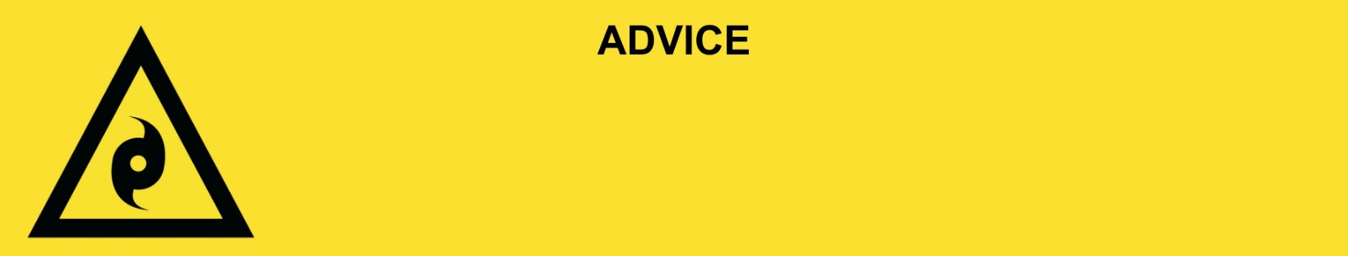
Issued: [time, day, date, year]
Next update: [time, day, date, year] or as the situation changes.

[Insert issuing agency] advises people in the following locations(s):
- [Add location(s) here]

to STAY INFORMED for storm surge from Tropical Cyclone [Name] that is [forming off / stationary off / moving [slowly or quickly] towards] the Queensland coast. Storm surge is a rise in sea level over and above the normal tide levels because of a cyclone. Storm surge is a threat to life and property.

For non-life-threatening flood and storm emergency assistance, contact SES on 132500, 132500.qld.gov.au, or the SES Assistance Qld app on Android or iOS. In a life-threatening situation, call Triple Zero (000) immediately.

What are we expecting?
The Bureau of Meteorology advises [insert BOM prediction here, including time/when it’s expected to hit].
- Waves and sea water will travel a long way inland and through coastal creeks and rivers. This can flood and damage buildings, wash away roads and cars, and damage bridges.
- Roads could be blocked by fallen trees, powerlines, or flood water from the cyclone.
- There will be lots of wind and rain from the cyclone. There will be flooding in low-lying areas.
- Power, water, phone, and sewerage services could stop working.

What you need to do:
- Never drive, walk, ride through, play or swim in flood water. If it’s flooded, forget it.
- Consider the consequences of road and bridge closures. Damage to roads, bridges or buildings caused by storm surge and landslip may exist in your area.
- Get and fill sandbags in case you need to block doors and stop water getting inside. You can get sandbags from XX.
- Use sandbags to block toilets, sinks and drains to stop sewerage backflow.
- Tell friends, family, and neighbours in the area.

If you find it hard to move quickly or have special or medical needs:
- Use your Person-Centred Emergency Plan (P-CEP) now if you have one.
- Make sure you have enough medicine for at least one week.
- If anyone in your house uses powered medical equipment, like a dialysis machine or ventilator, decide now where you will go in case you lose power.
- Call your support person or service to organise transport if you need to leave.
- Leaving early is safer than waiting.

If you are a tourist, visitor, camper or caravanner:
- Campers and caravanners should start packing up now.
- If you do not need to be in the warning area, leave now. Check road conditions and plan your route before you leave.
- Be ready to move if the situation gets worse.
- Ask the campground owners whether the site is affected by storm surge.
- Check your surroundings of water catchments, and monitor conditions.

For more information:
- Follow our local council disaster dashboard here [insert disaster dashboard link].
- Listen to your local radio [add ABC local radio or other station and frequency].
- For power outage information go to energex.com.au or ergon.com.au/network [select energy provider].
- Check the latest weather, warnings, rainfall, and river heights at the Bureau of Meteorology Queensland website.
- Check road closures at the QLD Traffic website or for phone service call 13 19 40.
- Check disruptions to public transport at the Translink website.

