MONITOR CONDITIONS
[Location]
Tropical Cyclone [Name]
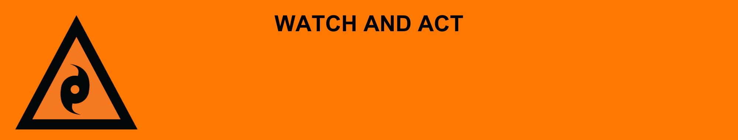
Issued: [time, day, date, year]
Next update: [time, day, date, year] or as the situation changes.

[Insert issuing agency] advises people in the following area(s):
- [Add location(s) here]

to MONITOR CONDITIONS for Tropical Cyclone [Name] that is [forming off / stationary off / moving [slowly or quickly] towards] the Queensland coast.

An [evacuation centre/registration point/assembly area] has been set up here (insert link/area).

For non-life-threatening flood and storm emergency assistance, contact SES on 132500, 132500.qld.gov.au, or the SES Assistance Qld app on Android or iOS. In a life-threatening situation, call Triple Zero (000) immediately.

What are we expecting?
The Bureau of Meteorology advises [insert BOM prediction here, including time/when it’s expected to hit/track map].
The tropical cyclone could cross the coast [near location / between location 1 and 2] by [tomorrow / day of the week e.g., Monday]. Conditions will get worse as it gets closer to land. You could expect:
- Very strong winds that could knock down trees, powerlines, and blow roofs off.
- Power, phone, internet, and water might stop working.
- Heavy rain [and storm surge] may cause flooding in some places.
- Roads could be blocked by debris or flood water. Some areas may be isolated.
- Stores may be closed and limit access to groceries and essential items.

What you need to do:
- Find out how to ready for a tropical cyclone at the Get Ready Queensland website (Get Prepared) and make an emergency kit.
- Clean up around your home and tie down anything outside that could blow away in strong winds.
- Tell friends, family, and neighbours in the area.

If you find it hard to move quickly or have special or medical needs:
- Use your Person-Centred Emergency Plan (P-CEP) now if you have one.
- Make sure you have enough medicine for at least one week.
- If anyone in your house uses powered medical equipment, like a dialysis machine or ventilator, decide now where you will go in case you lose power.
- Call your support person or service to organise transport if you need to leave.
- Leaving early is safer than waiting.

If you are a tourist, visitor, camper or caravanner:
- Campers and caravanners should start packing up now.
- If you do not need to be in the warning area, leave now. Check road conditions and plan your route before you leave.
- If you stay, ask accommodation staff where to shelter if the cyclone comes.

For more information:
- Follow our local council disaster dashboard here [insert disaster dashboard link].
- Listen to your local radio [add ABC local radio or other station and frequency].
- For power outage information go to energex.com.au or ergon.com.au/network [select energy provider].
- Check the latest weather, warnings, rainfall, and river heights at the Bureau of Meteorology Queensland website.
- Check road closures at the QLD Traffic website or for phone service call 13 19 40.
- Check disruptions to public transport at the Translink website.

