MOVE / STAY INDOORS
[Location]
Tropical Cyclone [Name]
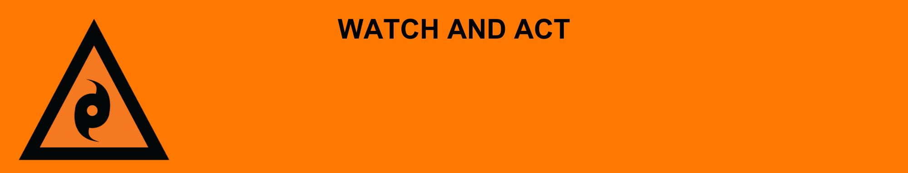
Issued: [time, day, date, year]
Next update: [time, day, date, year] or as the situation changes.

[Insert issuing agency] advises people in the following area(s):
- [Add location(s) here]

to MOVE / STAY INDOORS due to Tropical Cyclone [Name] has crossed the coast. It is still dangerous because of [strong winds/heavy rain/flood/lots of fallen trees and powerlines]. Stay indoors until you are told it is safe by [agency name].

If your life is in danger, call Triple Zero (000) immediately.

What are we expecting?
The Bureau of Meteorology advises [insert BOM prediction here, including time/when it’s expected to hit/track map].
You can expect:
- There to be [some/a lot] of damage.
- Some places are flood, some roads and bridges are blocked or damaged.
- There are fallen trees and powerlines and other debris outside.
- There may be damage to your home.
- Power may be off in places and could be for a long time.
- Some places may not have clean water. Tap water may not be safe to drink. Drink bottle water.

What you need to do:
- Stay indoors for your safety. If your shelter is badly damaged, move carefully to a safer place.
- If you have evacuated, stay where you are until you are told it is safe to leave.
- Roads may be blocked or badly damaged.
- Do not use generators inside. Fumes can be deadly.
- Limit use of devices to save batteries.

If you find it hard to move quickly or have special or medical needs:
- Use your Person-Centred Emergency Plan (P-CEP) now if you have one.
- Make sure you have enough medicine for at least one week.
- If anyone in your house uses powered medical equipment, like a dialysis machine or ventilator, decide now where you will go in case you lose power.
- Call your support person or service to organise transport if you need to leave.

If you are a tourist, visitor, camper or caravanner:
- Campers and caravanners should pack up now.
- Visitors should move to an evacuation centre, registration point or assembly area.
- Airports and highways could close if the tropical cyclone gets closer.
- If you choose to stay, ask accommodation staff where to shelter if the tropical cyclone hits.

For more information:
- Follow our local council disaster dashboard here [insert disaster dashboard link]
- Listen to your local radio [add ABC local radio station and frequency]
- Find out what to do during a cyclone Get Ready Queensland website
- For power outage information go to energex.com.au or ergon.com.au/network [select energy provider].
- Check the latest weather, warnings, rainfall, and river heights at the Bureau of Meteorology Queensland website.
- For emergency help in floods and storms, call the QLD SES on 132 500 or download the SES Assistance QLD App.
- Check road closures at the QLD Traffic website or for phone service call 13 19 40.
- Check disruptions to public transport at the Translink website.

