PREPARE NOW
[Location]
Flood (Descriptor)
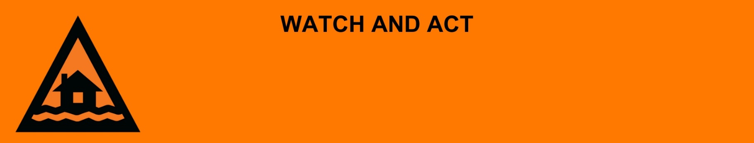
Issued: [time, day, date, year]
Next update: [time, day, date, year] or as the situation changes.

[Insert issuing agency] advises people in the following area(s):
- [Add location(s) here]

to PREPARE NOW for the [minor/moderate/major/flash] flooding on the [river/street/area name].

For non-life-threatening flood and storm emergency assistance, contact SES on 132500, 132500.qld.gov.au, or the SES Assistance Qld app on Android or iOS. In a life-threatening situation, call Triple Zero (000) immediately.

What are we expecting?
The Bureau of Meteorology advises [insert BOM prediction here, including time/when it’s expected to hit].
- Bridges and low lying roads may be impacted by floodwater.
- Transportation may be out of service.
- Once the floodwater reaches [X] metres, expected at [Time AM/PM today/tomorrow date], safe evacuation routes are likely to be cut off.
- You [may/will] become isolated until flood waters recede.

What you need to do:
- If you find it hard to move quickly leaving early is safer than waiting. Call your support service, a family member, or a friend to help.
- If it’s flooded, forget it. Stay out of flood water.
- Decide if you, and the people you live with, will leave if floodwaters get close to your house.
- If you have children make sure they are with you or an adult you trust.
- Be prepared to have no power. Charge mobile phones and other electronic devices now.
- Get and fill sandbags and block doors to stop water getting inside. You can get sandbags from XX.
- Use sandbags to block toilets, sinks and drains to stop sewerage backflow.
- Warn family, friends, and neighbours in the area. Help others if you can.

If you decide to leave early:
- Lift important things onto bed, tables, shelves or upstairs to protect them.
- Lift waste containers, chemicals, and poisons up high.
- Pack enough clothes, food, water, medicine, baby items (like nappies, formula) and pet food for [three / five / other] days. Plan not to have a fridge or microwave.
- Take your pets, mobile phone charger, battery-powered radio, torch, and valuables like photos, cash, and important documents (like identification, insurance, or banking records).
- Lock windows and doors.
- Go to a safe place, away from flooding. This could be with family or a friend.
- If you come to a flooded road, turn around and go another way. Do not drive through floodwater.

If you find it hard to move quickly or have special or medical needs:
- Use your Person-Centred Emergency Plan (P-CEP) now if you have one.
- Make sure you have enough medicine for at least one week.
- If anyone in your house uses powered medical equipment, like a dialysis machine or ventilator, decide now where you will go in case you lose power.
- Call your support person or service to organise transport if you need to leave.
- Leaving early is safer than waiting.

If you are a tourist, visitor, camper or caravanner:
- Campers and caravanners should start packing up now.
- If you do not need to be in the warning area, leave now. Check road conditions and plan your route before you leave.
- Be ready to move if the situation gets worse.
- Ask the campground owners whether the site floods.
- Check your surroundings of water catchments, and monitor conditions.

For more information:
- Follow our local council disaster dashboard here [insert disaster dashboard link].
- Listen to your local radio [add ABC local radio or other station and frequency].
- For power outage information go to energex.com.au or ergon.com.au/network [select energy provider].
- Check the latest weather, warnings, rainfall, and river heights at the Bureau of Meteorology Queensland website.
- Check road closures at the QLD Traffic website or for phone service call 13 19 40.
- Check disruptions to public transport at the Translink website.

